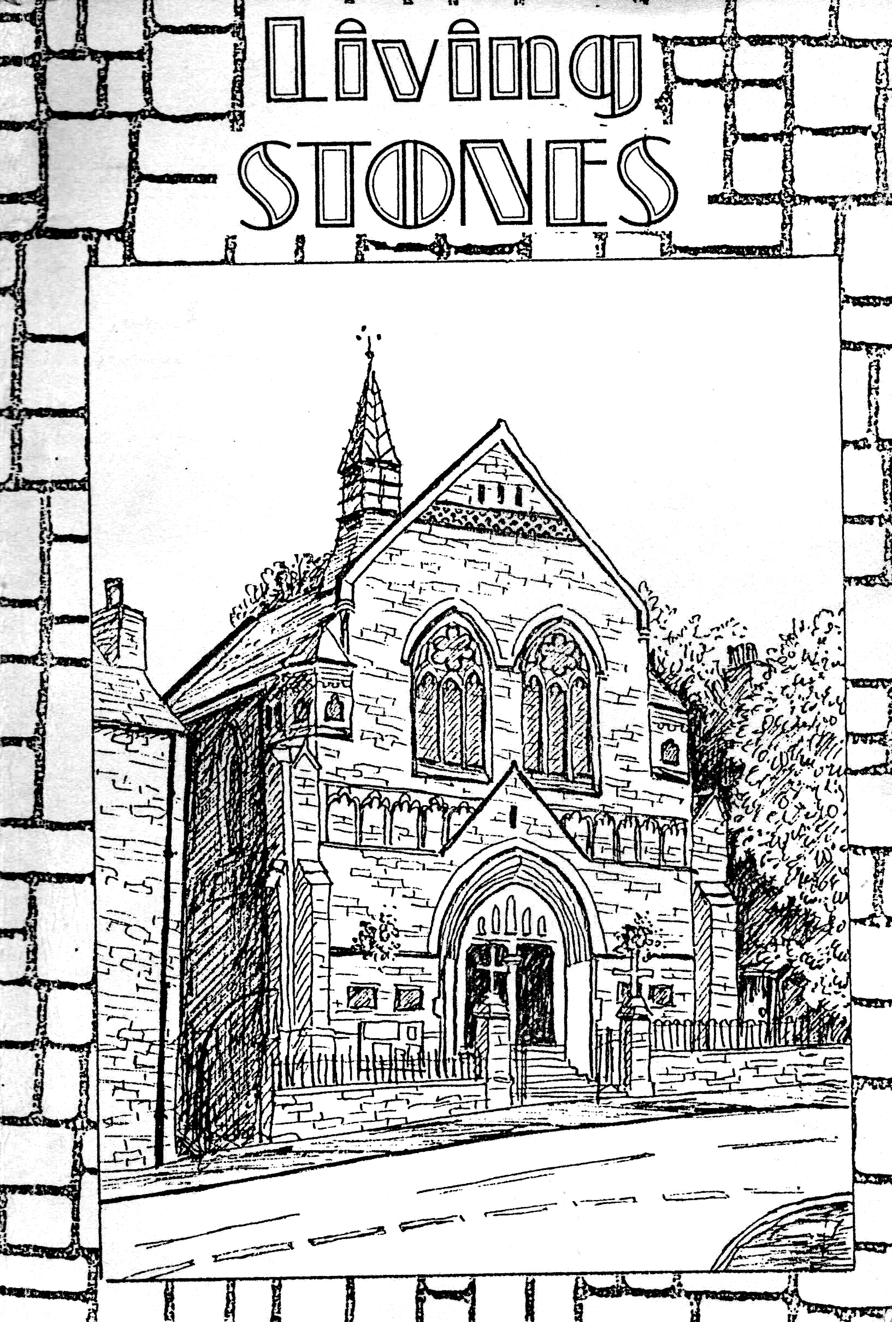

A History of
WIRKSWORTH BAPTIST CHURCH
1818 - 1986

Written to celebrate
the centenary of the present building,
March 1986

by Jenny Few

Wirksworth Baptist Church, 1986

First published in 1986 by Wirksworth Baptist Church
Correspondence to: J.M.Few,
26, North End,
Wirksworth, DE4 4FG
few.jenny@gmail.com

(c) 1986 by Jenny Few
ISBN 0 9511120 0 7

Printed and bound by:

MOORLEY'S BIBLE
& BOOKSHOP LTD.
23 Park Road, Ilkeston
Derbys. DE7 5DA
Tel: (0602) 320643

Foreword

On March 15th 1886, the new Baptist Chapel in Wirksworth was opened. It seemed a good idea, as we celebrate its centenary in March this year, to find out what has happened in the intervening years, and also to trace the story from the start of the church in 1818.
In many ways the story is a very ordinary one: the ups and downs of a smallish church in a Derbyshire town. There have been few dramas. But it is the story of ordinary men and women whose lives have been touched by the Living God and who have strived to serve Him in His church to the best of their ability, and as such it is a story well worth telling. In his First Letter in the New Testament, Peter says that Christians should be like "Living Stones", built up together into a "Spiritual Temple", and I have tried in the book to emphasise the people as well as the building. From the earliest days there have been some real "saints" at Wirksworth Baptist Church and I wish'I had had the space to write their personal testimonies: I hope I have been able to give glimpses of their faith and love for their Lord.
A lot of the information has come from the Church Minute books which are intact for the whole period covered by the book. Some of them are excellent minutes, full of detail and also legible! Others are just the opposite. I have tried my best to be accurate in every detail, but if there are any mistakes, I apologise in advance. The research reinforced my belief in the importance of good record keeping!
I would like to thank several people who have helped me: Mr. Robert Few, Mrs. Myra Collis, Mr. John Butlin, Mrs. Andrea Phillips, Mrs. Jean Radford and Rev. T. Budge, E.M.B.A. Archivist. Thank you also to Mr. Gavin Muschamp for the cover picture and the illustration on page 82. Thank you to the Community Education Department of the Anthony Gell, School, Wirksworth. Lastly, a special thank you to the late Mrs. Ida Thompson whose sure faith and keen memory inspired me initially.
Jenny Few
January 1986

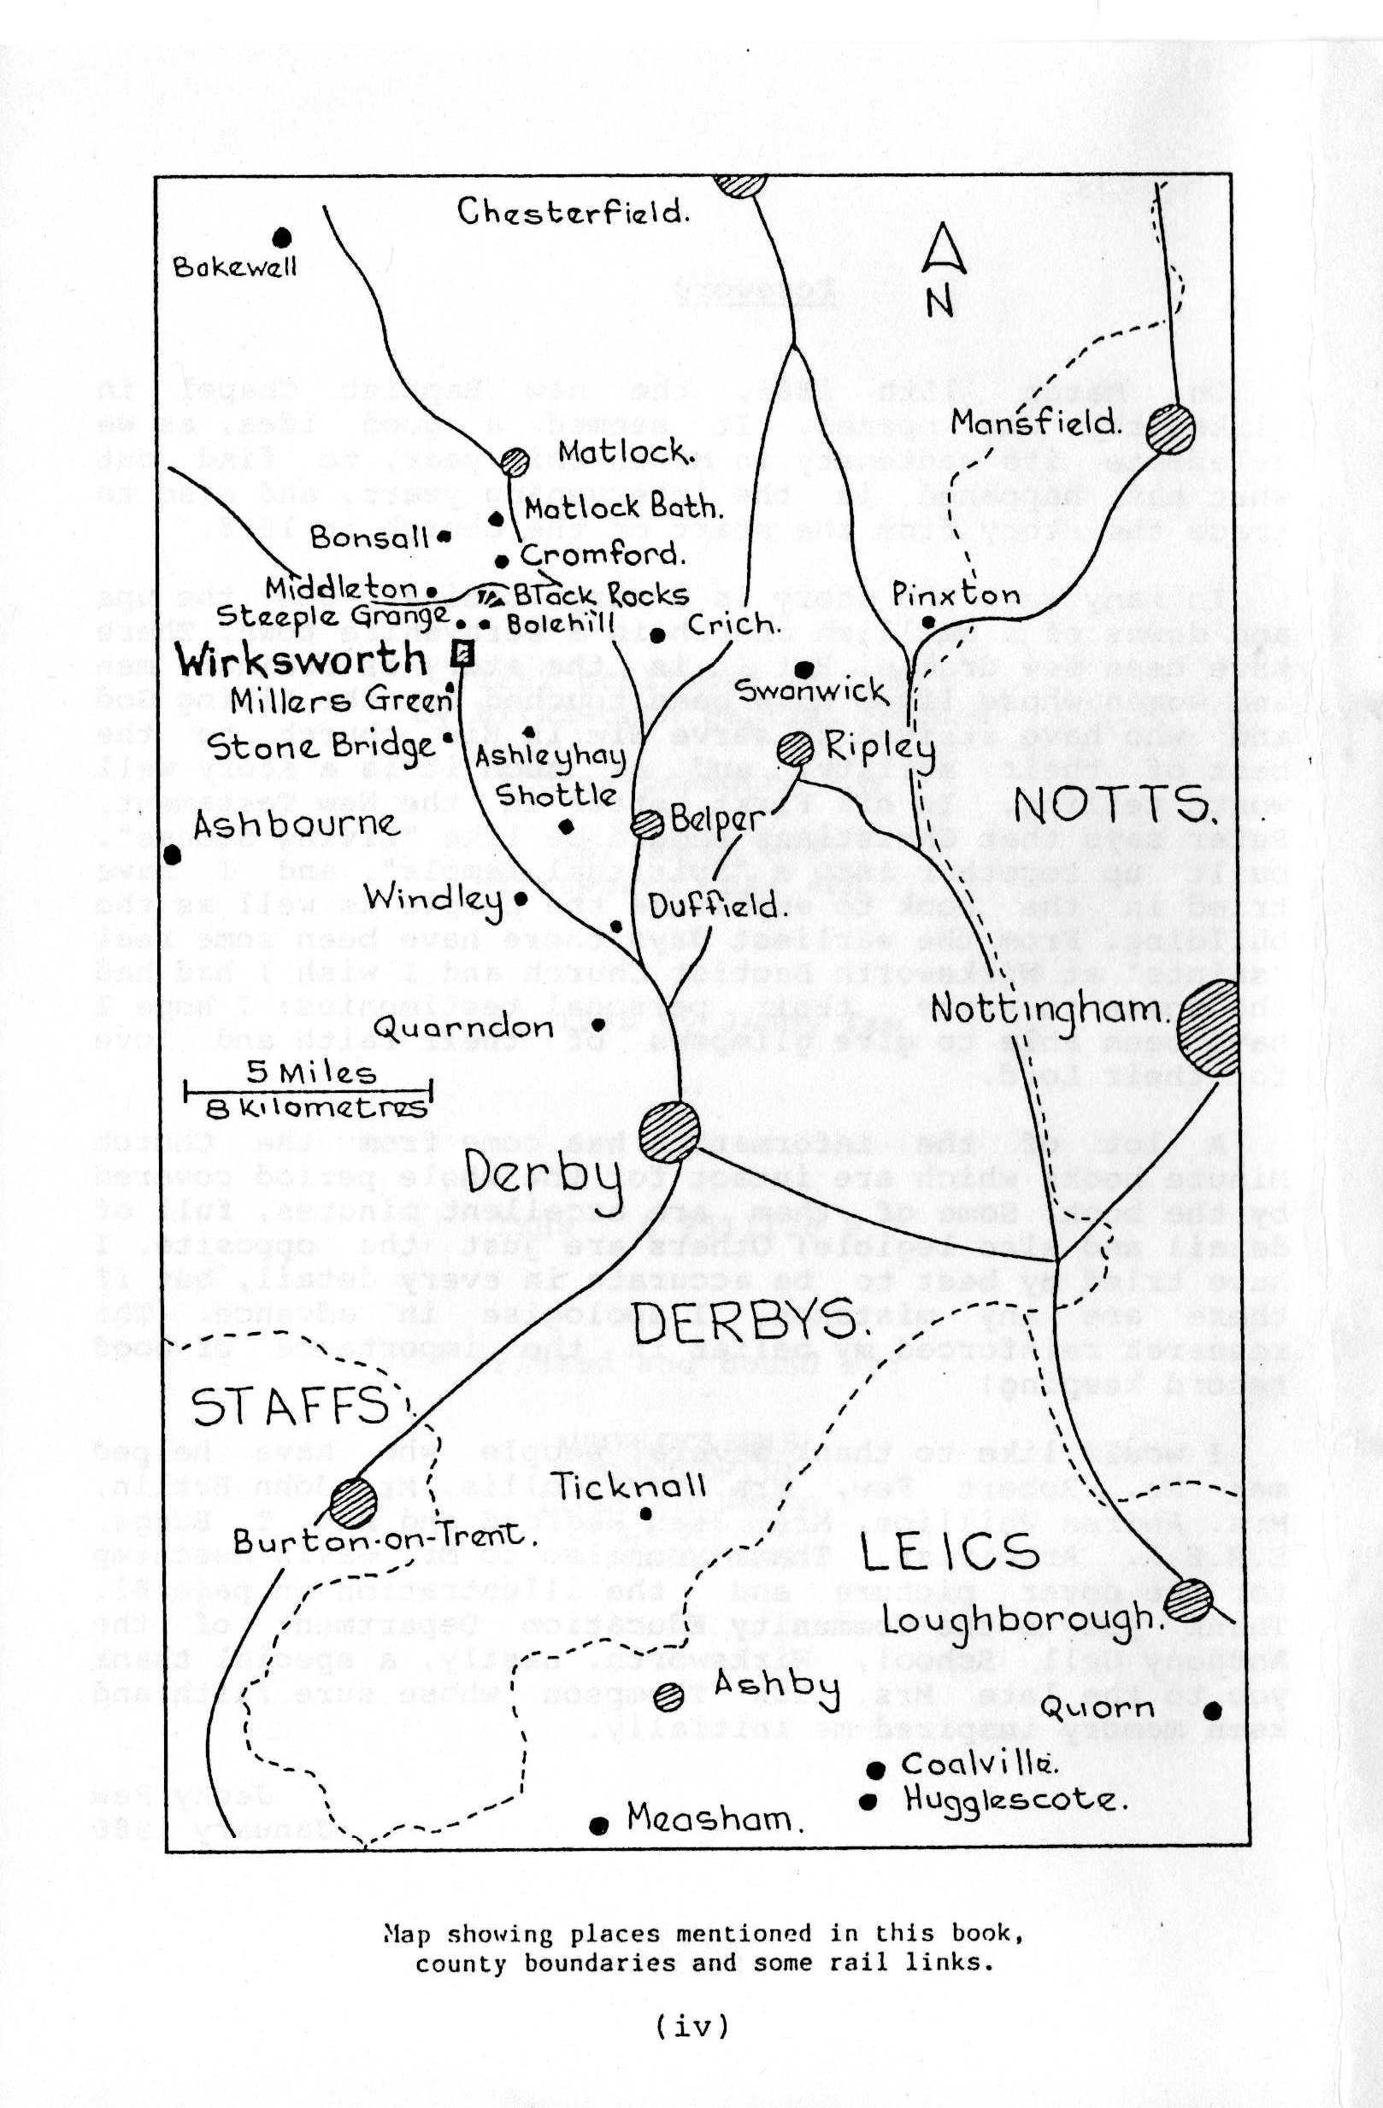

1. The Early Years : 1818-1879
On August 2nd. 1812, a Baptist preacher from Quarndon, Mr. Joseph Barrow, came to Shottle and preached a sermon in the home of Sarah Jackson. He attracted a keen group of worshippers around him and after several weeks started holding regular services in the local school-room on Sundays.
This was the start of Baptist witness in the area. During the next few months Mr. Barrow travelled to Wirksworth and several other surrounding villages, preaching and establishing local groups. His ministry was blessed abundantly by God "to the good of many precious souls".
He was originally connected with the Baptist Church at Duffield, but in the succeeding years spent more of his time with the growing fellowships at Wirksworth and Shottle. As a result, in 1818, he left Duffield: and the churches of Wirksworth and Shottle came into being as separate congregations.
The earliest recorded minutes for the Wirksworth church, dated June 19th 1818, read "Agreed that Brother George Malin of Shottle, and Brother William Smith of Stonebridge act in the capacity of deacons". It was a business-like start!
The following year, the church invited John Richardson from Ticknall to preach, and it is recorded that at a meeting on December 25th (!) they "unanimously agreed that we give Brother John Richardson a pressing invitation to come and reside amongst us". He accepted the invitation and stayed till 1835.
The building used by the Wirksworth Baptists from 1818 was not very suitable for its purpose. No picture exists of it, but this is how it is described: "Underneath was a stable; the approach was very objectionable: an uncovered flight of steps led to the room; a subterraneous passage to the school (when it was made) and a grocer's shop prevented it being seen". There is no indication of its size, but it is known that there was a gallery as well as the main body.
So this was the house of prayer in which the early Baptists worshipped and flourished. A Sunday School soon established and more deacons were elected to support the minister. Mr. Richardson was not supported financially by the church as he had secular employment. The church started to support the Baptist denomination very early in its history by sending donations to local association and sending delegates to the area meetings. (The Midland Association of General Baptist Churches was the fore-runner of the East Midland Baptist Association, which did not come into being till 1892.) Locally, the church saw itself as a missionary venture and, in the first few years, several preachers went Sunday by Sunday to the neighbouring villages, particularly Middleton, Cromford and Bonsall. The response was good everywhere they went, especially Bonsall. In 1822, Brother Job Worthy was asked to visit the owner of a piece of land "suitable to build a chapel on, and try to purchase it". The following year a committee was set up to make the necessary arrangements, and a chapel was built.
In the other villages, services were held in a suitable room or hall. In Middleton, Mr. John Spencer hired out a room for £l. 5s. In Shottle the church used a barn: "Baptists were upstairs and the cows downstairs, so that sometimes the lowing of oxen could be heard during services". As the years went by, people from Ashleyhay, Middleton, Cromford and other places came to Wirksworth to worship, so there were three separate fellowship - Shottle, Bonsall and Wirksworth - forming a Baptist Church together.
That they regarded themselves as one church is clear from the way they organised themselves. They shared their ministers and preachers and held joint church meetings. Deacons with particular responsibility for one of churches were elected at the Annual meetings, which was frequently held on Christmas Day. Wirksworth was largest church and was regarded by the other two as the parent body. In the Membership Book, the church is called "Baptist Church of Wirksworth, Shottle, Bonsall etc, until 1879! The group organisation seemed to work succesfully for most of the time.
Many people were baptised during the early years and the minute book records that "there shall be a meeting the morning of the Baptismal day at half past eight give a little advice to the candidates previous to their admission; and that the practice be continued". Baptismal services were usually held on a Saturday or weekday. The minutes also make clear the church's position on infant baptism : "any member taking their children to the font be sprinkled in accordance with the practice of the Church of England shall be liable to exclusion, because it is obviously unscriptural and tends to set aside the ordinances of Christ".
The earliest membership list dates from 1813, and records the names of Joseph Barrow, his wife Martha and another man from Quarndon, John Slack. Between August 1st 1813 and May 1818, there were 70 baptisms. The total number up to 1835, when Mr. Richardson left, was 359. The church was therefore thriving and the members were aware of God's blessing upon them.
Many decisions affecting the organisation and conduct of the church were made in the first decades. By 1824 there was a group of trustees and several more deacons (who were chosen by ballot). The members were urged to commit the matter to the "Great Head" in prayer and then write their choice on a piece of paper. "These all were then thrown together and afterwards sorted and the highest numbers be considered as the person elected". Membership was a serious commitment and there are several instances of members being dismissed for improper conduct. The church disapproved of people being members of the Church of Christ and of the Society of Oddfellows at the same time. (The person concerned was not expelled from 'the church however as the deacons could not agree about it, and the matter was referred to the Midland Conference.)
The church also disapproved of the practice of Christmas singing "as being unscriptural, and highly unbecoming those who profess to be Dissenters".
Some members were erased from the church roll or excluded from membership and some left of their own accord. There were several who left to join the Congregationalists or the Plymouth .Brethren or even "the Church". Several were also restored to membership after a time of exclusion. Rules of membership were evidently stricter then than they are now. A close watch was kept by the deacons on church attendance, particularly attendance at communion services. Perhaps the fact that pew rents were paid in those days had something to do with this!
After Mr. Richardson left in 1835, he was succeeded by Mr. Underwood, who stayed till 1841. These were years of great enthusiasm and outreach, and Wirksworth, together with other South Derbyshire churches, met to encourage Baptists in the north of the county. As a result of this zeal, and with financial assistance also being given, the Baptist church in Chesterfield came into being at this time. (It is noted that this was an unusual procedure:-small village causes helping a church in a larger town. Nowadays it would be the other way round.) Mr. Kenney, who succeeded Mr.. Underwood, visited Chesterfield frequently to preach and encourage the church. He was held in high esteem by the Chesterfield Baptists.
In 1848 Mr. Stannion from Derby became minister, and he and his wife Rebecca enjoyed a fruitful ministry. The total membership shortly after he left in 1856 was 186. During his ministry a plot of land was purchased on North End for £140 for use as a place of burial "according to the dictates of our conscience and by our own ministry".
Mr. Thomas Yates from Hugglescote, Leicestershire, succeeded Mr. Stanion in 1854, and he did much to improve the organisation of the church: with more regular lists of members revised frequently. Regular minutes of meeting were kept. The church was in a healthy and vigorous state during his ministry, although never well-off financially.
After he left, the church was served by several ministers who stayed only a short while. In 1879, the Rev. Caleb Springthorpe from London was invited to become minister at an annual salary of £120. It was during his ministry that the new chapel was built.

2. The New Church Building – 1886
In 1877, the Baptists at Shottle were given the opportunity to build a new chapel when the owner of the barn, the Duke of Devonshire, wanted to pull it down. After several anxious visits by Shottle and Wirksworth deacons and a lot of correspondence, the Duke granted a new site for a chapel together with a donation of £50. The chapel was built at a cost of £300.
This venture at Shottle must have had some influence on the Wirksworth members, who perhaps began to look at their building and wish for something better! Mr. Springthorpe was very keen on the idea of a new church, but nothing could be done until the grocer's shop and house in front had been bought by the church. This was not easy because the property was owned by a minor in her teens and a tenant, Mr. Palin, lived there. However, advice was sought and eventually the shop was bought for £500 (which was exactly twice what it had been sold for in 1836).
At this point in the story, the Spencer family begin to figure prominently. Mr. Robert Spencer and his wife Mary retired to Wirksworth from Manchester in 1871, and joined the church. He became a deacon and when he died in 1882 he left a legacy of £500 to the church. His brother George, trustee of his will, began to take an interest in the church's plans and offered much valuable advice and assistance during the next few years. The will states:
"....that my trustees shall pay a legacy of five hundred pounds at any time after my decease when and as my said trustees or parties entitled, to the dwelling house and shop and premises adjoining the Baptist chapel at Wirksworth aforesaid recently contracted to be purchased shall deem it requisite and proper to take down, alter or improve and thereby also alter, enlarge and improve the Baptist chapel adjoining thereto". It was this legacy which enabled the church to rebuild completely; rather than altering the existing premises.
An architect, Mr. Wallis Chapman from London, was invited to draw up plans and a local firm of builders, Messrs. Walker & Sons, were engaged to do the building.
A picture of the chapel, together with an appeal for subscriptions, was published and widely circulated. The estimated cost was £2,200. At the time of the appeal, £400 had been raised by the church, £250 was in hand from bazaars, making a total of about £1200 (including the legacy). The appeal concluded with these words: " Men, brethren and fathers, hear ye this our first and earnest appeal for help!"
In 1884, Rev. Springthorpe was Chairman of the Midland Conference of Baptist Churches and in this capacity he visited many churches in the area, preaching and appealing for money.
Early in 1885, Mr. Palin left the shop and the last services were held in the old church. These took place on Sunday, March 22nd., and the occasion must have been tinged with sadness for many of those present. Six people who had been members for more than 50 years were there. They were:
Samuel Jennens, baptised in 1818
Henry and Hannah Taylor, baptised in 1823
John Worthy, baptised in 1826
Mary Houghton, baptised in 1829
William Hatfield, baptised in 1833
Several people were baptised at the last service: Mr.and Mrs. Poyser, Hannah Potter, Mr. Lavidge, Elizabeth Wain, James Hatchett, Eva Potter, Betsy Land, Anna Marie Waywell and Emma Frith.
So the old building came down and work began on the new. It was constructed of stone from Black Rocks quarry and Mr. Andrew Bridge's quarry, Matlock. Plans were made for the opening to be held in February 1886, but it soon became clear that it would not be completed on time. The church decided to impose fines on the contractors if there was any unnecessary delay!

In May 1885, the foundation stones were laid by Mr. William Richardson; Mr. Thomas Spencer, nephew of Robert Spencer; Mr. John Keys, from Derby; and Mr. A. Y. Springthorpe, who was the minister's son and lived in London. The Derbyshire Times reported this event, and it is worth quoting it at length:
NEW BAPTIST CHAPEL - Memorial Stone Laying
"A ceremony which appeared to excite a very considerable degree of interest took place in Coldwell St. Wirksworth on Monday last at 2.30. The thoroughfare was nearly blocked up by a large crowd, and there were dotted about ladies and gentlemen whose evident interest in the proceedings was unmistakeable. There were many others who showed by the serious earnestness with which they listened to what was going on that they had not joined this large crowd simply from motives of curiosity. The crowd was seemly, well ordered, quite befitting indeed the serious, very important occasion which had brought them together. It is always a subject of gratification to find places for religious worship springing up in any town, and it must have been a proud moment for the minister and members of the Baptist denomination to see such a gathering."
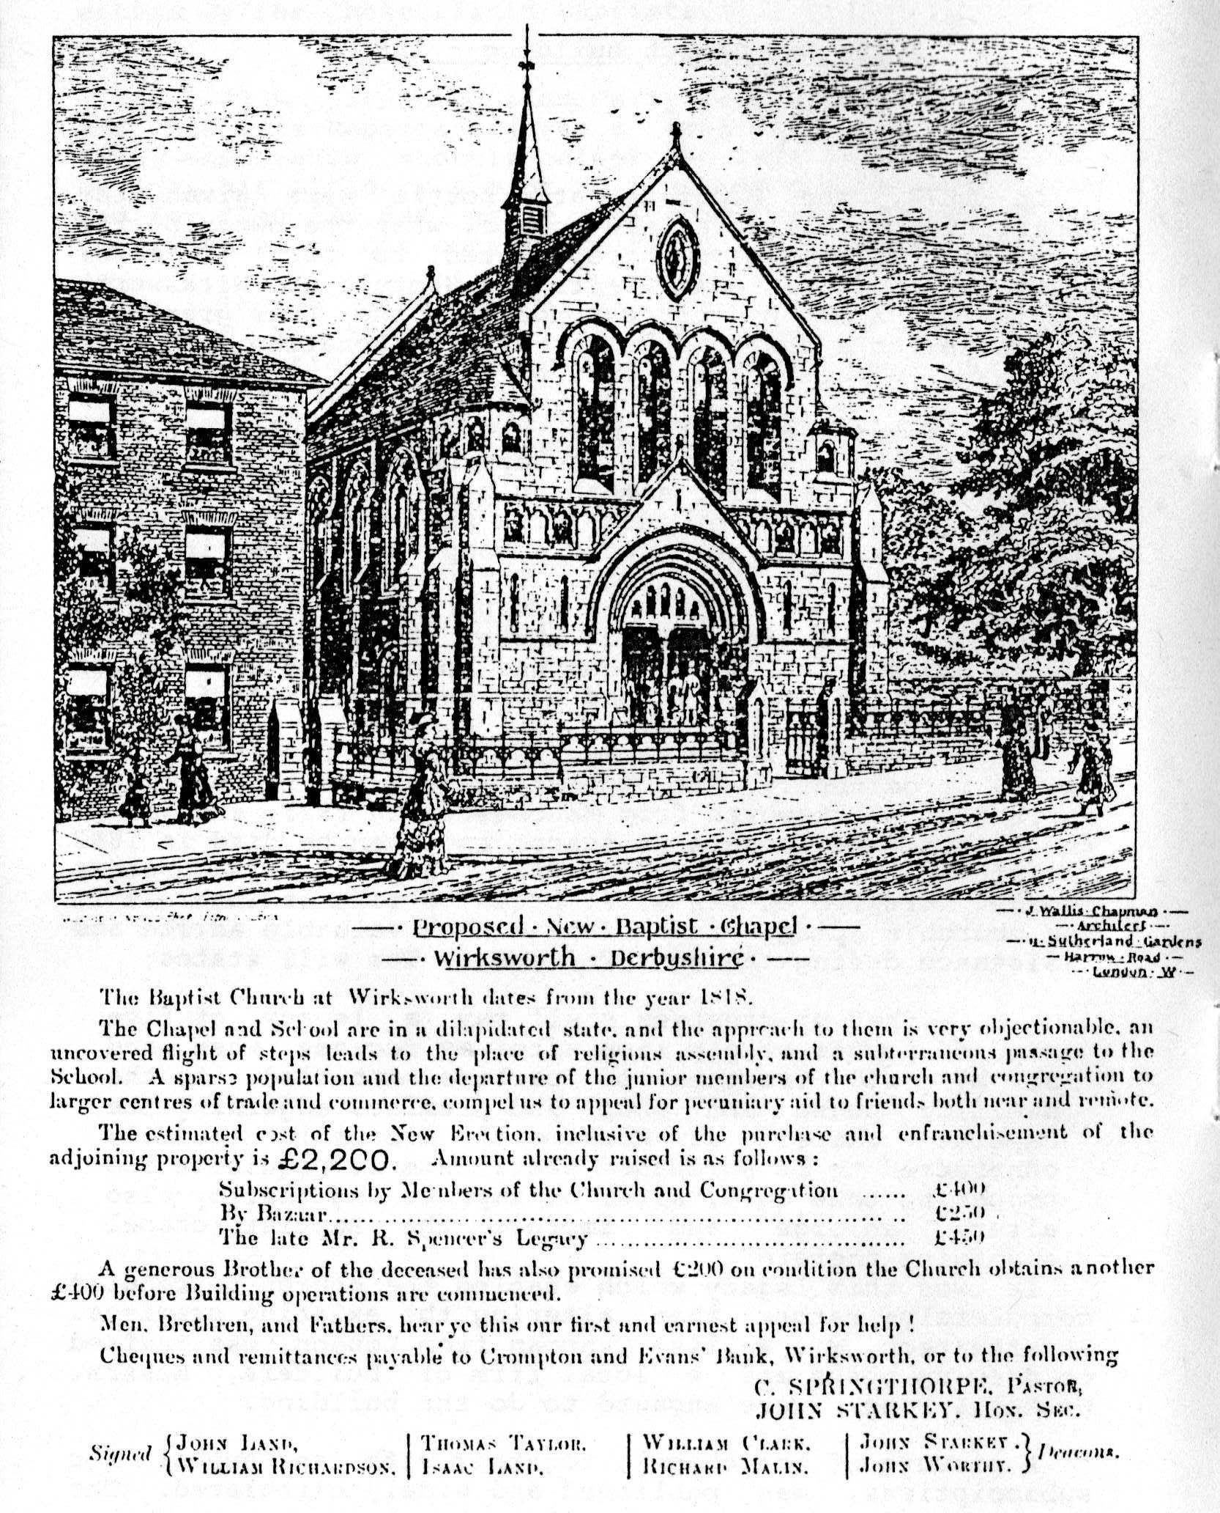
Details of the procession from the Town Hall follow, and then the speech made by Mr. Starkey, Church Secretary, is quoted:
"We shall have accommodation for as many in the new chapel without a gallery as we had in the old; besides which we shall have a schoolroom and classrooms and two vestries, a lobby for conversation, and indeed, every apparatus for a church all alive. Not a penny will be wasted. No towering spires will salute the sky for we cannot afford them even if we wanted them. No painted windows will dim the light. Indeed, utility and economy will rule throughout. We shall have a real home for Christian hearts, a good drill-ground for Christian soldiers, and a good-sized auditorium for preaching the glorious gospel of the Blessed God in all its glorious breadth and fulness".
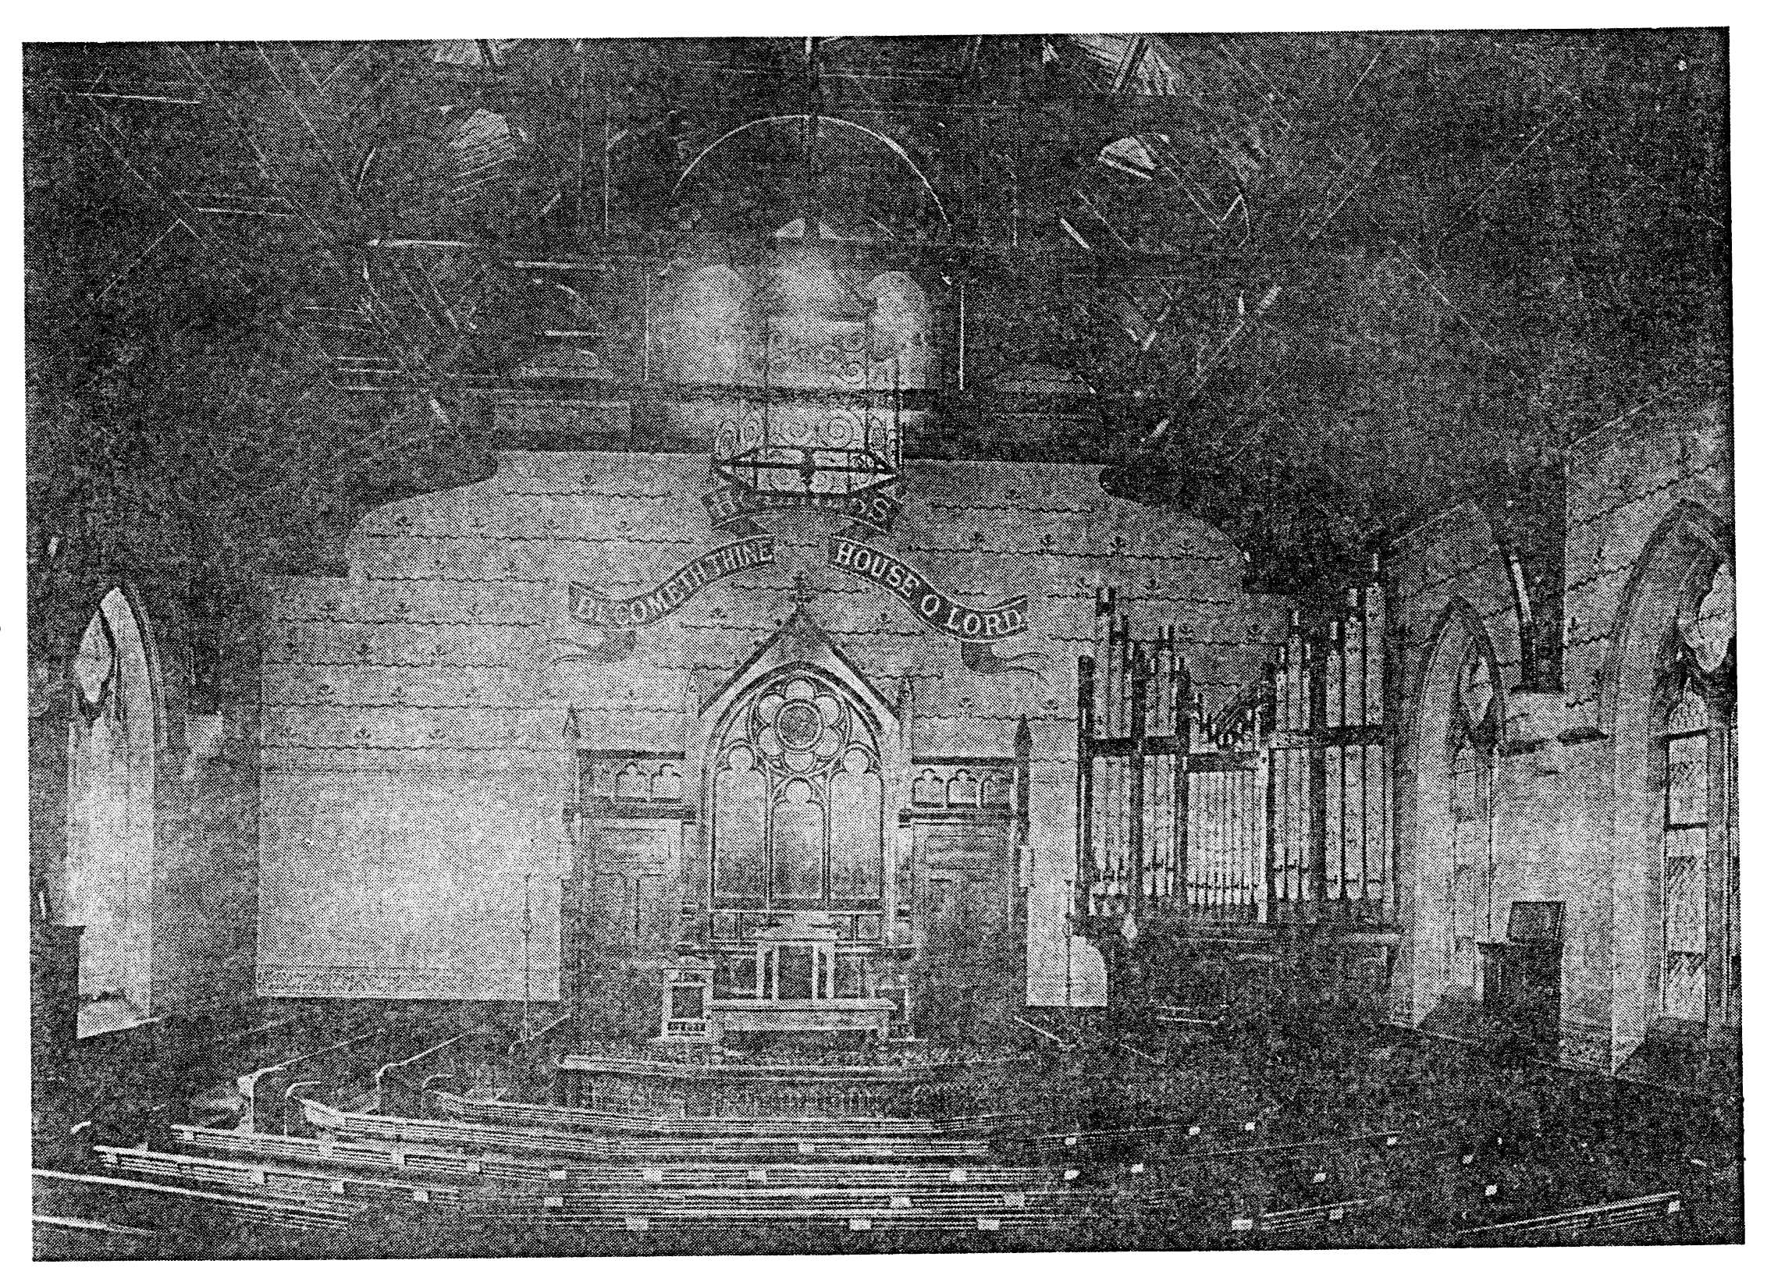
A bottle was deposited under one of the stones, containing copies of the General Baptist magazine, some coins and a programme of the last service in the old building, together with a list of all who were there. A silver trowel with an ivory handle was used for the stone-laying. There was a ceremony for the Sunday School children too, and several of them carved their initials in the plinth. Tea at the Town Hall followed and was attended by visiting ministers, Members of Parliament and the Mayor and councillors. The Derbyshire Times reporter approved of this large gathering, which "would do credit to any religious community". Addresses were given by eight people, including the minister and the senior deacon, Mr. William Hatfield.
After this excitement, the church returned to the more mundane task of fund-raising and making plans for the interior decoration of the new church. An elegant gas chandelier was designed by Mr. Chapman. Services were held at the British School, of which Mr. Starkey was the Headmaster. In November 1885, two more memorial stones were laid in the partially-completed vestibule, by two members of the Malin family from Shottle. In January 1886, the church decided to install a pipe organ to replace the harmonium used in the old chapel. Mr. Starkey and Mr. Clark were empowered by the members to buy the organ from Mr. J. Porrit, organ builder, of London Rd., Leicester, for the sum of £130. This was not fully installed for the opening ceremony, but was in full use a few weeks later. The opening was arranged for Monday, March 15th, with a service followed by a Public Tea, tickets Is each or 6d for children. (All the workmen were given a free ticket.) Guest preacher for the occasion was Rev. Dr. J. Clifford from London.
Once again, the Derbyshire Times reported the event approvingly:
Opening Ceremony of Baptist Chapel
"(The chapel) is a graceful and well-proportioned edifice in the gothic style. The floor is raised from the pulpit and the seats are fixed octagonally so all will be able to focus attention on the preacher without straining. This is a reform to which more attention should be paid in all modern religious structures".
The church members were also delighted with their new building. It was deemed "commodious, handsome and suitable for all the needs of the congregation and Sunday School". The printed programme for the opening ceremony included the words of the Te Deum:
We praise Thee, O God;
We acknowledge Thee to be the Lord.
All the earth doth worship Thee,
The Father Everlasting.

3. Wirksworth in 1886
The new chapel was opened at a time when the town of Wirksworth itself was undergoing a "face lift", with several other notable new buildings being completed about the same time - reflecting the national confidence of Queen Victoria's England.
The TownHall was built a decade before, its
foundation stones having been laid during Wakes Week,
September 1871, amidst great celebrations, with processions, flag waving, etc.
The Cottage Hospital, on Greenhill, was a source of great pride for the townspeople and was generously supported by several of the wealthier families of the town.
Undoubtedly the greatest improvement for the town in the second half of the 19th Century was the coming of the railway in 1865. The line, linking Wirksworth with Duffield and Derby, was greeted with great celebrations on its opening day, with processions and parades, a public luncheon at the Red Lion and games on the Hannages. It was a triumph for the people of the town, who had worked hard to get the line built. For the ordinary people of the town, it became the main link with the outside world. Apart from the High Peak line at Steeple Grange, the only other means of transport available was the road: a slow and hazardou.-i prospect. There was a public carrier ;i'm vice, and some goods were moved by waggon, but the railway was a great boon to tradesmen and passengers alike. (The line closed as a passenger link in 1947.)
A book written shortly after 1900 comments that at the end of the century, there had been a lot of improvements to the amenities in the town - besides the railway. There was now a better water supply to all parts; gas lighting had been installed in the streets; and the roads themselves had been remade and improved. There was an excellent postal service - 3 deliveries per day and one on Sundays! There were 3 banks in the town.
At the beginning of the century, the main occupation for the townspeople was still the lead mines, but these gradually declined and closed during the 1800s. Work in the limestone quarries and tape mills replaced the lead mines, so that the pall of smoke which overhung the town from the lead smelting was replaced by a cloud of limestone dust.
Of course, farming was an important job for many people living in the outlying areas and the weekly market was a lively, thriving place: meeting in the old Market Place, a much larger area than it is now that Harrison Drive has been cut through.
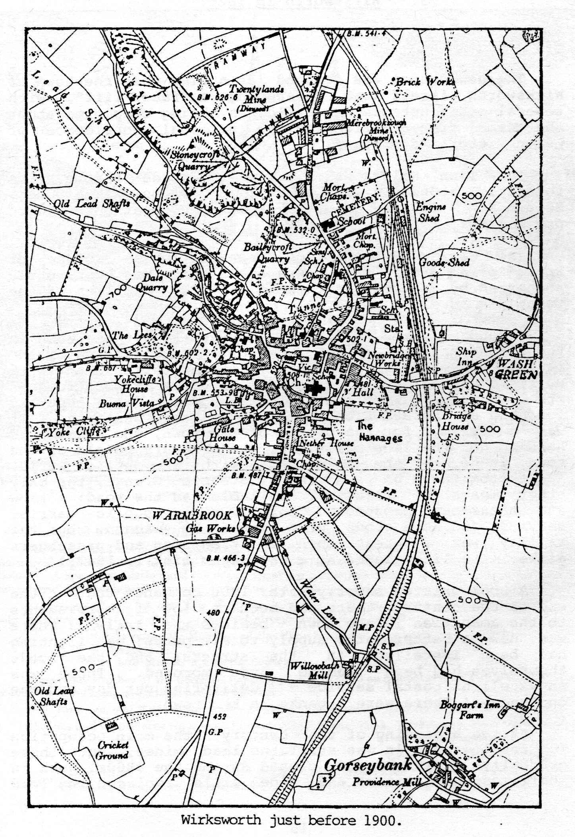
As well as the British School on Chapel Lane, there was the National School on North End, built in 1851 at a cost of £1,457.3s.4d. (This is now Mrs. Tucker's Infant School.') The Anthony Gell Grammar School occupied an elegant building in the church close. The Church of England School on North End - now for infants - was built in 1896.
There were many places of worship in the town in 1886. One writer of the time comments "no town in England for its size is better represented with non-conformist churches than Wirksworth". The Congregationalists were the oldest established, their church being rebuilt in 1866 on the site of a much older Presbyterian chapel dating from 1700. This building is reputed to have had shutters at the windows, so that the worshippers could meet in secret.
There were three Methodist chapels: Wesleyan on Chapel Lane; Primitives in the Dale; and United Methodists on St. John Street. A Temperance Hall was built in 1860, and became the home of the Salvation Army; the Church Army had premises in the Dale; and the Moot Hall, built in 1814, was used by the Brethren.
Dominating the town, then as now, was the Parish Church of St. Mary, built over several hundred years in all the main architectural styles. Some restoration work was carried out in 1877 by Sir Gilbert Scott.
So the new Baptist Church took its place with all the other places of worship and earned the description as the "prettiest of all the places of worship in the town".

The new chapel was opened at a time when the town of Wirksworth itself was undergoing a "face lift", with several other notable new buildings being completed about the same time - reflecting the national confidence of Queen Victoria's England.
The Town Hall was built a decade before, its foundation stones having been laid during Wakes Week, September 1871, amidst great celebrations, with processions, flag waving, etc.
The Cottage Hospital, on Greenhill, was a source of great pride for the townspeople and was generously supported by several of the wealthier families of the town.
Undoubtedly the greatest improvement for the town in the second half of the 19th Century was the coming of the railway in 1865. The line, linking Wirksworth with Duffield and Derby, was greeted with great celebrations on its opening day, with processions and parades, a public luncheon at the Red Lion and games on the Hannages. It was a triumph for the people of the town, who had worked hard to get the line built. For the ordinary people of the town, it became the main link with the outside world. Apart from the High Peak line at Steeple Grange, the only other means of transport available was the road: a slow and hazardous prospect. There was a public carrier ;i'm vice, and some goods were moved by waggon, but the railway was a great boon to tradesmen and passengers alike. (The line closed as a passenger link in 1947.)
A book written shortly after 1900 comments that at the end of the century, there had been a lot of improvements to the amenities in the town - besides the railway. There was now a better water supply to all parts; gas lighting had been installed in the streets; and the roads themselves had been remade and improved. There was an excellent postal service - 3 deliveries per day and one on Sundays! There were 3 banks in the town.
At the beginning of the century, the main occupation for the townspeople was still the lead mines, but these gradually declined and closed during the 1800s. Work in the limestone quarries and tape mills replaced the lead mines, so that the pall of smoke which overhung the town from the lead smelting was replaced by a cloud of limestone dust.
Of course, farming was an important job for many people living in the outlying areas and the weekly market was a lively, thriving place: meeting in the old Market Place, a much larger area than it is now that Harrison Drive has been cut through.
As well as the British School on Chapel Lane, there was the National School on North End, built in 1851 at a cost of £1,457.3s.4d. (This is now Mrs. Tucker's Infant School.') The Anthony Gell Grammar School occupied an elegant building in the church close. The Church of England School on North End - now for infants - was built in 1896.
There were many places of worship in the town in 1886. One writer of the time comments "no town in England for its size is better represented with non-conformist churches than Wirksworth". The Congregationalists were the oldest established, their church being rebuilt in 1866 on the site of a much older Presbyterian chapel dating from 1700. This building is reputed to have had shutters at the windows, so that the worshippers could meet in secret.
There were three Methodist chapels: Wesleyan on Chapel Lane; Primitives in the Dale; and United Methodists on St. John Street. A Temperance Hall was built in 1860, and became the home of the Salvation Army; the Church Army had premises in the Dale; and the Moot Hall, built in 1814, was used by the Brethren.
Dominating the town, then as now, was the Parish Church of St. Mary, built over several hundred years in all the main architectural styles. Some restoration work was carried out in 1877 by Sir Gilbert Scott.
So the new Baptist Church took its place with all the other places of worship and earned the description as the "prettiest of all the places of worship in the town".

4. The Church is the People!
The Christian Church is not primarily the building, or even the Organisation, but the people who meet together for worship. So, who were the people who belonged to the Baptist: family in 1886? There were about 80 members at this time, some of them from families which had been associated with the church from its beginning. Inevitably, there is more in the church records about the officers than other members, so we can take a closer look at some of them.
Mr. John Henry Starkey was Church Secretary from 1874 till 1924.. He and his wife, Catherine, moved from Coalville, Leicestershire,in 1871. Mr. Starkey was Headmaster of the British School, Chapel Lane (where the Glenorchy Centre now is). They lived at "Middle Peak View", Cromford Rd., and both were in their late 30s in 1886. Mrs. Starkey devoted herself to the poor and needy in the town and "exercised a ministry of quiet devotion among them". They had 2 adopted children living with them, James and Minnie Hatchett, both of whom later became church members. James became church organist and treasurer and he worked as a bank clerk in Derby. He was one of the group baptised at the last service in the old building, as was the Starkeys' live-in maid, Annie Marie Waywell.
Mr. Robert Spencer, who left the legacy of £500, lived at 16, St. John's St. with his wife, Mary. He had been a succesful tradesman in Manchester before retiring to Wirksworth, and he was 90 when he died.
The Church treasurer, Mr. Samuel Allsopp, was 70 and lived with his wife, Ann, at 15 St. John's St. He was a joiner by trade. They had one daughter, Sara, and a grand daughter, Emma Frith, who later joined the church. Two families of Allsopps lived on North End. Mr. John Allsopp was a saddler, and was baptised in 1877. There is a note next to his name in the membership book: "to be seen by the minister", which sounds ominous! His wife was not a church member. In the other family, the parents did not belong to the church but several children and grand children were baptised in later years.
Deacon Isaac Land lived at Millers Green and was a joiner. He was in his fifties and had two children, Bertha, who worked as a maid, and a teenage son, John.
Another large Land family lived at Bolehill. John Land, a lead miner, was a deacon and his wife Martha was also a church member. They were both in their fifties in 1886, and had 9 children living at home. Three sons became lead miners, another was a factory hand and another an apprentice stone mason. Several of them joined the church, including Samuel, who was church treasurer for many years. He became a draper, owning a shop in the Market Place where the chip shop now is. Other members of the family were connected with the Pentecostal Church, and more than one became a minister of a Free Evangelical Church. They were also a very musical family, singing in the choir and providing soloists for special occasions.
The Minister in 1886, Rev. Caleb Springthorpe, lived with his wife, Ann Marie, at 47, North End. They had at least one grown-up son who lived in London.
The Taylor family was very prominent in the church at this time and continued to be so until the 1950s. Mr. Thomas Taylor, a master mason, lived at 28, West End. He was a deacon and local preacher and his wife, Jane, was also a church member. They were baptised in 1850. Their two sons, John and Henry, also joined the church and John in particular played a leading role as deacon. He is warmly commended by the church as the "worthy son of sainted parents". Further up West End lived Henry Taylor,a retired stone mason, and his wife Hannah. They had been church members for 50 years and sadly.they both died in 1886, shortly before the new building was completed. Other branches of the Taylor family lived at Warmbrook and the Dale.
William Hatfield, Sunday School Superintendent, also lived at West End. He was a tailor by trade.
George Malin was a local preacher and it was his two sons who laid the memorial stones in the vestibule. His ministry was particularly in the villages. Many members of the Malin family belonged to the Shottle Church, and it is a name which occurs throughout the church's, history. Samuel Greatorex was also a member of the church at Shottle and was a deacon and local preacher. It was said of him: "his robust Christianity would not conform to what he believed unscriptural".
Other families associated with the church were the Friths, the Goulds, the Barkers, the Beestons, the Clarks and the Ric'hardsons. Most of the members were natives of Wirksworth, with only a few moving from other towns. Most entered the church by baptism, rather than profession of faith, and for most it was death that separated them from it. A few younger people left the town in the early 1880s, but it was not until the early years of the 20th Century that the population became significantly more mobile. There seems to have been a good cross-section of the community in the church, ranging from professional people to master craftsmen and labourers. There were a few shopkeepers too and quite a number of young women worked as domestic servants. Several members also worked on the railways. Very few travelled outside the town to work.
In addition to the members, there were many people who attended services and supported the church on special occasions. The tape mill owner, Mr. George Wheatcroft, was a friend of the church; as was Mr. Joseph Wheatcroft, J.P., who donated £100 to the building fund.
These then were some of the people in the Baptist family in 1886; and we shall meet many more as the story goes on.

5. Into the Twentieth Century
The first years following the opening of the new church proved to be difficult ones, especially after the Rev. Springthorpe left.
There were many financial problems: the loan to the Baptist Union had to be repaid in instalments; and the organ, though installed, was not paid for. The church decided to hold special events to raise money and they pledged themselves to raise £100 by the end of 1888 to help pay off the debts.
For the organ fund, special Services of Song were held and organ recitals given. Some members gave very generously, Miss Emma Alsopp receiving special thanks for her efforts. Mr. Joseph White was presented with a hymn book for playing the organ, although whether this was for a recital or regularly for services is unclear.
The ladies sewing circle was resumed early in 1888, to make things for a Bazaar which the church planned for later in the year. All ladies were urged to attend this and. work hard for the effort. These sewing meetings must have been very happy occasions. Tea was served and often there was a speaker or someone who read to the ladies as they worked.
Another problem facing the members was that of pulpit supply: Bonsall and Shottle as well as Wirksworth. Mr. Starkey had the job of arranging this; and it is noted that he, John Taylor and William Young undertook to lead one service a quarter each. Plans were made quarterly, with the deacons from all three churches meeting on a Tuesday evening to arrange the services and discuss other group business. At the end of 1887, they decided not to look for another minister straight away; although several students from the Baptist College in Nottingham came to preach and at least one of these was considered for the pastorate. There did not seem to be much of a problem filling the pulpits. Preachers came from as far away as Derby, Burton on Trent and Leicester, as well as the local area. Those from far away were given hospitality and, if it was a special occasion, stayed the night to take another service the following day.
There were several minor teething troubles with the new church: not least a disagreement with the owners of the neighbouring house regarding ownership of the dividing wall and the gable-end of the house. This was resolved and a special stone was put into the wall, inscribed to the effect that the wall and gable-end were joint property of the church and house.
1889 began with a review of the financial situation. A committee - Mr. Allsop, Mr. Starkey, Mr. Taylor, Mr. Clark and Mr. Buxton - was appointed to "wait on members and congregation to ascertain what they will give towards clearing of the £200 in Messrs. Cromptons' Bank". As a result of this appeal, several people paid money which they had earlier pledged and others promised new amounts ranging from £1. to 5s. A group of ladies also promised either sums of money or goods. The church at Bonsai1 offered to pay £2 per quarter to the general fund if and when a suitable minister came. ilt is not clear at this stage what Bonsai1 or Shottle had previously contributed to the finances, as there is no record of early financial statements.)
In June 1889, Rev. B. Noble, of Measham, came to take a service and, at a tea meeting held the following Tuesday, it was unanimously decided to invite him to become pastor. He readily accepted and was invited to come again on the Sunday preceding the Bazaar, in Wakes Week, in September, and stay on till it was over.
The Bazaar was to be a two-day event in the Town Hall: with admission of 6d on the Monday and 3d. on the Tuesday. Musical items were planned and tea was served. Handbills and posters advertised it all over the district and it was most successful - but there is no record of how much was raised!
The ministry of the Rev. Barmforth Noble began in the autumn, when he and his wife Anna Marie came to live in the town. A recognition service was held on Monday, November 11th, followed by tea. All the ministers of the town were invited, together with friends of the church from further afield. These included Mr. Thomas Spencer, and also Rev. S.S. Allsop from Burton-on-Trent. (.This name is mentioned many times; he was invited to take special services on several occasions and obviously has an interest in the church. It is possible that he was a member of the Wirksworth Allsop family, of which there were several branches at this time.)
Rev. Noble's ministry lasted until 1905 and, during that time, the church grew and some of the financial burdens were lifted. In March, 1890, there were eight baptisms and later that year, Monday evening prayer meetings and Wednesday evening services were resumed. The next few years saw a steady growth in numbers and a healthier financial situation, so that, in 1892, Mr. Noble's salary was raised to £110 per annum - "but not guaranteed". There is no record of what it was when he came.
Two members of the church, Mrs. and Miss. Wilkins from Black Rock House, started a library in the church, with books from the Religious Tract Society. The members welcomed this effort very enthusiastically and pledged themselves to use it and recommend it to others.
At this time, the church was in a position to help and encourage another local church which was rebuilding. A donation was sent to the Baptists at Belper and an optimistic letter was sent in reply, thanking them for their gift, and reporting 11 recent baptisms, "with more soon following".
1897 was an important year for the church. The building was now 10 years old and the members decided to do some decorating and minor repairs in the church and school room. The estimated cost was £44.10s. The services were to be held in the Town Hall for five Sundays during the summer while the work was carried out. There was also a long discussion about the feasibility of moving the organ and repositioning it behind the pulpit. This would have cost £350, which was too much. Mr. Noble, an organ builder from Derby, came to dismantle and rebuild it in its original place and Mr. James Hatchett, the organist, urged that some additional stops be installed at the same time. When this was done, a contract was made to have the organ tuned three times a year for £2.5s.
When the decoration was finished, the church decided to buy new carpets for the pulpit and communion area, making the total cost £170. The church was reopened on the last Sunday of July, with good congregations and a collection of £37 was taken.
The other major event of 1897 was the withdrawal of Bonsall from the group. There seems to have been a long-standing disagreement between some of the members of the two churches and tensions arose when the Minister took services at Bonsall, leaving Wirksworth to supply its own pulpit. It was also felt that the Shottle people were not receiving enough pastoral oversight. A special church meeting requested that "the Friends at Bonsall withdraw from the Wirksworth Church and join themselves into a separate church and provide for the supply of the pulpit after the 31st of December, as Mr. Noble will discontinue his pastoral oversight at Bonsall on that date". This decision was accepted by the Bonsall church,and it is recorded that in March of the following year, 16 members of the Wirksworth church transferred their membership to Bonsall, making their membership about 30.
Soon after this break, a meeting was held between the officers and minister and all the Shottle members to consider the future of the work there. The first decision made was to start the afternoon service at 2 p.m. instead of 2.15: "this being deemed more convenient for our friends in sending off their milk". Mr. Noble agreed to visit Shottle to preach three times instead of only twice a quarter, and he undertook to do more pastoral visiting. It is noted that "the meeting was very cordial especially on the part of our Shottle friends, and everyone left the chapel hopeful for the future".
Throughout this period, there was a healthy and happy relationship with the other free churches in the town. The Free Church Council met regularly: joint services and social events were held. The ministers of the other churches were invited to the Church Anniversary and other special occasions. There are several mentions of applications for baptism by Methodist and Congregationa1ist friends - though what their own ministers thought about that is not recorded! There was also a friendly, if more distant, relationship with the Parish Church: the secretary wrote a warm letter of condolence to the widow on the death of the vicar, Rev. T. Smith, in 1893.

As the Church moved towards the 20th Century, all its activities appear to be flourishing. The choir sang regularly at services and bought lots of new music. They also enjoyed outings and social activities. As well as the prayer meeting and the week-night service, there was now also a Christian Endeavour Society. Sunday services were well attended and the ministry of Mr. Noble appreciated. However, there is a strongly-worded note in November 1898, urging that the morning service must start promptly at 10.45. - and then it was "proposed, seconded and carried without opposition that the service stop at 12 o'clock"! It was also proposed that during the winter months the caretaker should light the fire on a Friday evening to make sure the chapel was warm enough for Sunday. The Sunday School was well supported too, and the Anniversaries always a highlight of the year. James Hatchett, the organist, trained the children for the anniversary, which resulted in such good singing that "the Baptist Sunday School Anniversary is known far and wide".
The cemetery was, of course, still the responsibility of the church - in particular a board of trustees elected to look after its affairs - and there are two mentions during the 1890s of gifts of laurel plants and other flowering shrubs and plants for the paths and grassy areas.
At the Annual General Meeting of 1899, there is the first recorded survey of the year's work by the minister. "It was not discouraging", he said,"but it called loudly for more united prayer effort". Also at this meeting, the church decided to suspend Christian Endeavour in favour of a new young people's meeting which had recently started. The church decided that they would support the Baptist Union's Twentieth Century Appeal, launched that year. This was designed to unite the denomination and to raise money for the B.U. The appeal took several different forms, including a "million shilling " fund. A good start was made by the church as a gift of 100 shillings was promised straight away.
So the 20th Century arrived, and with it, several changes for the church. The first was the complete repayment of all the church's debts, which was celebrated by a special tea meeting in July. It is recorded that a "fair number sat down, and the meeting which followed was of a very homely character". As well as the giving of the members, a generous gift from Mr. Joseph Wheatcroft had enabled all the debts to be paid. A warm letter of thanks was sent to Mr. Wheatcroft.
At the A.G.M. that year, an additional committee was appointed from the membership to help the deacons and do business not requiring a church meeting. The reason given for this was the "increasing uncertainty in the attendance of several of the officers consequent on age and infirmities". Those appointed were J. Taylor, R. Taylor, J. Hatchett, S. Land and R. Johnston. None of the deacons were young men. Mr. John Starkey the secretary was the youngest at 52. Of the others, John Land and Isaac Land were 72; Samuel Allsop was 85; and William Clark and William Richardson must have been about the same age, having been baptised in the 1850s. The new committee were younger men: Samuel Land was John Land's son, and was 31; James Hatchett was the adopted son of the Starkeys, and was 32; John Taylor was the oldest of the committee at 41; the other two also being in their 30s.
The point about age and infirmity was taken up by the minister in his report, stating that there had been a large number of deaths during the year and an unprecedented number of cases of illness. He also referred to the condition of the prayer meeting, which had not been well attended, and which he felt was vitally affecting the life and usefulness of the church. "There is much need for serious prayer and effort and thought "In the last twenty years or so, the church had experienced the loss by death of many of its keenest members. This was already beginning to affect the life of the church before the rebuilding in the 1880s. Now, those that were left were getting old and it seemed they were reluctant to hand over the reins completely to the next generation.
The membership in 1900 stood at about 80.
The following year, the church was encouraged when a mission was held in the town, resulting in many converts. It is interesting to see how the church followed up the people referred to them. Six women members were appointed to visit the women converts and four men to visit the male converts. At the next church meeting, reports were given on a large number of people and some of them were accepted for immediate baptism and membership. It is clear though that a larger number were "held over" to a later date. There were some candidates from Shottle, with more to be visited by the minister. Those to be baptised in Wirksworth were:
Mrs. Agnes Waywell Thomas Wetton Pollie Steeples Fred Nixon
Ethel Webster John Shaw Mary Tunnicliffe Lizzie Hawley
Annie Waterfield Agnes Stirzaker
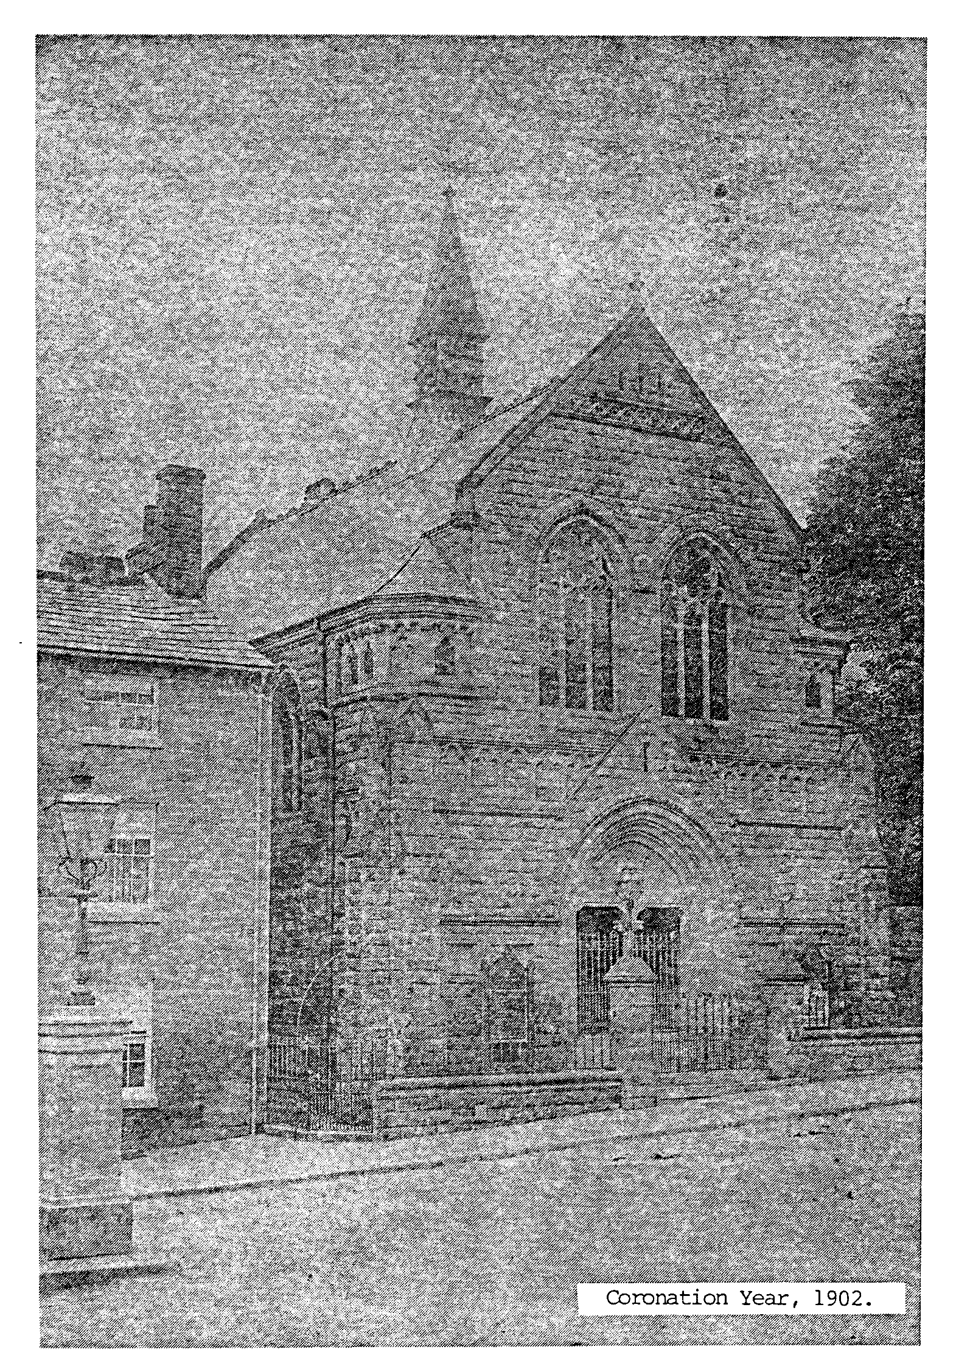
Mary Waterfield The membership book records that they were baptised on Wednesday evening, April 24th, 1901. As a result of the mission, the Christian Endeavour Society was re-formed with the new converts in mind.
A sad note in 1901 was the death of Mr. George Spencer of Manchester, "our most esteemed and valued friend". The members wished to put on record "our sincere gratitude to God for his helpful generosity to this church during the period of its greatest undertaking, viz. the erection of our present beautiful sanctuary".
In 1902, the church again decided to hold a bazaar to boost funds. This was to be in October, in the Town Hall, and was to be held over two days. There were many stalls, including a Japanese stall, a "fine art gallery" and a bran tub. Photographs of the chapel were ordered at 6d each to be sold for Is. It was emphatically decided there should be no raffle. The minutes record that it was "deemed wise to apply for the services of a policeman each day to keep the staircase and doorway clear of children". The bazaar raised £105.12.2d, which was a cause for great satisfaction when reported to the A.G.M.
At that meeting, Mr. Noble urged the members to think more about the spiritual side of the church now that there was more money as a result of the bazaar. He again stressed the need for more people to attend the prayer meeting "if there was to be any effective soul saving".
About this time, the church received a legacy from the estate of Mr. William Smedley, amounting to £22.10s. After a lot of debate, it was decided to invest this separately in a Baptist Manse Fund. This is the first mention of a manse, and it is assumed there wasn't one at this time, the ministers either providing their own house or living in rented accommodation. During the next few years, several more legacies were added to the fund, and in time a plot of land was bought for £120, but the minutes do not record where this was.
During 1903, the church played host to the County Union conference, and also gave generously to the British and Foreign Bible Society centenary appeal. A total of £63.lis was sent to the B.U. Twentieth Century Fund. The following summer, Mrs. Williams paid for Rev. and Mrs. Noble to go to the Keswick Convention.
Several more repairs and alterations were made to the building, including matting down the aisles - to cover the worn linoleum, but also to "deaden the sound of feet". Some additional lights were also installed, two near the pulpit, and two near the rear door.
At the A.G.M. in 1905, "an ample and sumptuous tea was provided, to which a good number sat down with relish". During the business part of the meeting, three life deacons were appointed: Mr. J.H. Starkey, Mr. Isaac Land, and Mr. William Richardson.
In March that year, Mr. Noble was given two weeks extra holiday because of ill health, but it soon became clear that this was rather serious because, in April, he resigned on the advice of his doctors. His letter goes on: "Having given to the church for Christ's sake 15 of the best years of my life, I cannot help having a deep interest in her future course, wherever my lot may be cast. We have had gracious reaping times in the past, though the more recent years have been times of strenuous sowing for the most part, sometimes even with tears. But is not this the pledge of further reaping in the days to come?" The church reluctantly acceptd his resignation and he left at the end of April. His health must have recovered, because he continued his ministry in Brearley, Yorkshire.

6. Years of Progress : 1905-1914
During the interregnum in 1905, the deacons took on the responsibility of arranging the preaching plan for Wirksworth and Shottle and the running of the church. One of the first things they did was to appoint a Board of Trustees for the cemetery. They were Messrs. John Starkey, James Hawley, William Richardson, John Taylor (Haarlem), John Taylor (West End), James Hatchett, Samuel Land, Frederick Poyser, Thomas Land, Robert Johnston, Frederick Nixon and Richard Taylor. The fees for interment were also revised and a notice-board made for the gate. (There are several recorded instances of chickens and other small creatures belonging to neighbours houses causing a nuisance in the cemetery. On at least one occasion the caretaker had to call in the constable .)
Another Board of Trustees was set up to look after the manse land. They included all the cemetery trustees with the addition of Mr. Thomas Spencer and Mr. Noel Wilshire, who, with his wife Grace, had recently joined the church from Manchester. No decision was made to build a house on the land; it was leased out to three of the church members, at 30s a year, for use as an allotment. The wall was repaired and a notice put up, saying "Site for Baptist Manse".
There was no problem finding preachers for the Sunday services. Several ministers from Derby were willing to come, as were students from the Midland Baptist College, and there were several excellent preachers among the members.
So the life of the church went on throughout 1905, with only a few minor problems. A new heating system was installed which worked very well after initial teething troubles. A letter was written to the vicar when it was discovered that trees in the neighbouring vicarage garden were blocking out the light and also damaging the roof tiles and guttering. There was also an occasional problem from people habitually lounging on the church steps Inspector Davis was called in to deal with it. The church was in good heart, although Mr. Starkey made a plea for greater unity and for more loyal attendance at the morning service. He also urged that members should encourage their friends and relations to come to church.
A sad event in February 1906 was the death of Mr. William Spencer of Manchester. Mr. Starkey wrote a letter on behalf of the church, which was very warm in its praise of Mr. Spencer's "genial Christian deportment, and gracious and unostentatious liberality". A wreath was sent to the funeral.
The church began looking for another minister in the autumn of 1905, and in March the following year, Rev. R.T. Anderson of Northampton came to preach at the Church Anniversary services. He was invited to become minister at an annual salary of £120. His letter of acceptance is very wordy!
"My dear Christian friends,
After much prayer that our Heavenly Father might make the way very clear, and that I might know no will in this matter but His, after much thought as to the possibilities of the work in your sphere, after coming among you and having personal contact with you as a people, I write to say that in humble dependance on the Spirit of God for strength, I accept the invitation you have given me to become your pastor".
There is a lot more in similar vein!
He and his wife moved in the summer and lived in a house in Bolehill. The service of recognition was held in August and was attended by many visiting ministers and friends. The main speaker was Rev. Joseph Gott from Northampton, who preached on "He that winneth souls is wise". After a public tea, there was an evening meeting at which Mr. Anderson spoke. He thanked the church for their warm welcome and spoke of his belief that there was a common bond between " all churches that are free and evangelical. “We agree at the Cross of the Lord Jesus Christ, therefore all other things must be relegated to second place. "
In September, all the organisations within the church began their autumn programmes. At Mr. Anderson' suggestion, the Christian Endeavour was to try "cottage meetings" during the winter months. The sewing circle began again, young people's meetings were to be held on Sundays, and the Wednesday fellowships were to start with studies of characters from the writings of John Bunyan. A Young Men's Mutual Benefit Society was also formed.
An encouraging letter was sent to the church soon after the start of Rev Anderson's ministry. It was from the old students of the Midland Baptist College, and reads:
"Dear Brethren,
We, the old students of the Midland Baptist College, desire to congratulate you on the settlement of Mr. Anderson as pastor of your church. Not a few of us remember visiting you and your kindness has created in us a personal interest in your welfare. We believe that, in Mr. Anderson, you have an able and worthy minister of Jesus Christ and we sincerely pray that your united services may be owned of God in the great advance of the Kingdom of God in your town and district".
The letter came from Woodborough Rd Church, Nottingham.
In January 1907, a baptismal service was held, when Mrs. Allsopp, Sissie Taylor, Gertie Waywell and Arthur Taylor were baptised. The A.G.M. later that month found the church in good heart and sound finances.
Mr. Anderson also visited Shottle, of course, and, during March 1907, he held a series of five special meetings which were very well supported. True to his sentiments expressed at the service of recognition, Mr. Anderson also supported the Free Church Council, although his plans for a united mission in the town appear to have come to nothing.
At the annual meeting the following year, there was a deficit of 17s 11d, which sum was immediately offered by someone in the meeting. The minute book records: " this generous offer touched the hearts of all present'. It being suggested we should sing the Doxology, we did so with full hearts".
1909 saw several changes to the church when two of its most loyal members died. Mr. William Richardson, who was a life-deacon and had served the church faithfully for half a century, died early in the year. He left a legacy of £25 for the manse fund. And in the summer, Mrs. Catherine Starkey, wife of the secretary, died. Mr. Starkey presented a set of individual communion cups to the church "in memory of my late dear wife." A cupboard was built in the vestry by Mr. Beeston to house them and they were dedicated at a memorial service. The inscription reads:
"This communion service was given to the Wirksworth Baptist Church by John Starkey and family in memory of his beloved wife, Catherine Starkey, who for 37 years loved and laboured here".
A new order of service was introduced for the communion service at this time and the church was following the new practice of the denomination in using individual cups. The old set, consisting of a flagon and chalice, were to be offered to Shottle, until it was realised that they too had been presented as a memorial gift. This plan was scrapped, with letters of apology sent to the family concerned.
(The new communion set is the one still in use today. The plates used for the bread are even older, having been presented to the church in 1878 by Mr. William Clark. They were therefore used in the old church building.)

Also. in 1909, the treasurer, Mrs. Allsopp, resigned. She had taken over the job from her husband a few years earlier. They were both in their 70s and Mr. Allsopp had died in 1904. Mrs. Allsopp died in 1911. Mr. Samuel Land became treasurer in her place. He and his wife, Minnie, had recently endured great sadness when their baby son died.
A Sale of Work was held in the Town Hall in December 1909, and there were some interesting side shows: weight guessing competition, nail driving, lady's whistling, gentlemen's hat trimming, gentlemen's washing, cake making and bran tub. Unfortunately, there is no record of how much was raised.
Rather surprisingly, a letter of resignation was received from Rev. Anderson in December, after he received an invitation from a church in Lincoln. He had stayed less than four years, and one wonders if his ministry, after so much initial promise, was not very successful. Perhaps it is significant that a much more rigorous procedure for choosing future ministers was agreed by the church meeting. He left in February 1910, with many expressions of regret by the church members and a testimonial in the form of a gift of money.
As usual, the task of arranging pulpit supply and organising the church was done by the deacons. Mrs. Robert Johnston offered to arrange hospitality for visiting preachers. The church paid 4s for Sunday only, and 6s for the whole weekend. (The Johnstons had joined the church in 1896, when they moved from Leamington Spa. Mr. Johnston owned a hardware shop in the Market Place, where the Delicatessan now is. He was a Sunday School teacher and leader of the Christian Endeavour, and was highly respected by his fellow deacons: "although not a native of Wirksworth, he has so put all his love and devotion to the Master into the cause at Wirksworth that he is entirely one of us" )
In September 1910, Rev. Isaac Ward from Leicester came to preach and to meet the members of Wirksworth and Shottle churches. After his visit, the deacons appealed for a good attendance at the church meeting to consider him. Two members had visited his church in Leicester, and there were also letters from a former pastorate in Sheffield. The vote was held by ballot and proved to be "perfectly unanimous in favour of Mr. Ward." He was invited to begin his ministry in November, and a happy recognition service was held, with many musical items arranged by Mr. Hatchett.
His ministry lasted seven years and during that time the church continued steadily, with little obvious change. Several older members died and gradually more younger people took over the responsibility for the various organisations. Mr. and Mrs. Ward were obviously very happy in the church and, during their time, more social events were held. They celebrated the anniversary of their pastorate each year with an "At Home". At one of these, Mr. Ward entertained the gathering with some reminiscences of his life at sea! A party was held every Christmas, usually on Boxing Day, with games and music often going on until 11 o'clock. The church was very busy organising the usual special events during the year. The Harvest Festival was always a particularly busy time: many people in the church and town provided produce for the display, and a group of men from the church would travel round collecting it on whatever conveyance they had. The ladies collected items for "tea trays". This often took the form of a gift of money rather than food items.
The church continued to take an active part in the work of the denomination locally. Delegates were sent to all the meetings and there were representatives on the missionary committees. A lively missionary delegation week-end was held annually in February. In 1911, the B.M.S. appealed for 150,000 shillings - an appeal which was left to members’ discretion to support.
Several repairs and improvements were made in the church. Members sitting at the back complained of a draught, so the builder was invited to make plans to improve the entrances. New, modern W.Cs. were to be installed and folding doors were put on the organ. No progress was made on plans for a manse. There was more money in the fund following the death of Miss. Holbrook in 1910, but the only work done was to repair the wall. It is also noted that Mr. Johnston gave up his share of the land to Mr. Hatchett.
At a church meeting in October 1911, the members were told that of the original 15 Church Trustees, only 4 were still alive. An election was held to bring the number up to 15 again, and those appointed were Messrs. James Hatchett, Robert Johnston, John Taylor (senior), John Taylor (junior), Fred Nixon, Harry Buxton, Richard Taylor, William Spencer, Fred Poyser, Samuel Land, Alfred Wardman, Noel Wilshire, Herbert Leatherland, Thomas Land and Norman Malin.
Although several older members had died in recent years, the membership remained about the same, with a steady number of baptisms and transfers. There were 12 baptisms during Mr. Anderson's ministry and an average of 4 or 5 per year during Mr. Ward's seven years. Of these, the majority were the children or younger relatives of existing members. One or two came from other churches, including Miss. Florence Ward, who came to Wirksworth from Townhead Church, Sheffield, which closed down. In 1914, Mr. and Mrs. Butlin joined the church from Junction St., Derby. Several members of the Malin family also came to Wirksworth during this time, leaving the church at Shottle. The membership in 1-915 was 91, plus 27 at Shottle.
Financially the church managed to pay its way. More than once, if there was a deficit in the accounts at the A.G.M., Mr. Ward offered to sit in the vestry and receive gifts. On one occasion, he reported that 62 people had contributed £21.2s 9d.. In 1913, the chapel was thoroughly cleaned and decorated at a cost of £27. The work was done by Mr. J.K. Fritchley and paid for out of the legacy of the late Miss. Holbrook. In June, a flower festival was held in the church. This included flower arranging competitions for adults and children. Winners received copies of a book called "Congo Land".
In 1914, the church was honoured by the appointment of Mr. John Starkey as President of the County Union. Mr. Ward wrote in the minute book:
"We offer our cordial congratulations to our esteemed church secretary on his election ….Mr. Starkey's work and his integrity as a witness to Baptist principles and practice for over 40 years are thus recognized. This honour reflects honour on the church he has served so long".
Mr. Starkey marked the occasion by presenting the church with a portrait of himself to hang in the deacons vestry.
An "At Home" meeting was held later in 1914, and it is recorded that "a fine enthusiasm pervaded the meeting, addresses were given by all the deacons, and the three lady soloists were much appreciated". It was in that spirit that the church entered the war years: united and rejoicing, under the leadership of a loved and respected minister.

7. The Great War : 1914-1918
During the years which were to bring so much change to the fabric of society, the life of Wirksworth Baptist Church.continued in much the same way as usual. The first reference to the war comes in September 1914, when the Annual B.U. Assembly was "abandonned". Quite a number of men associated with the church joined the army or some other branch of war service and, in October 1914, a list of those volunteering was written into the minute book. They were: Charles Barker, Alec- Ault, Willie Ault, Archie Ault, Leonard Kirk, Alfred Taylor, John R. Taylor, James Else, James Brooks, J.Hands, J. Ward, J. Wood, Samuel Johnson, James Hawley and John Oxspring. At first the names of all those joining the colours were read from the pulpit, but some members objected to this, so a Roll of Honour was begun and placed in the vestibule.
In 1916, the church decided to insure the premises against air raids, at a cost of £2. This was renewed the following year. The church also invested some money in the war loan. Later in 1916, the time of the evening service was changed to 6 o'clock and blackouts were put on the windows.
Apart from these precautions and the occasional shortage of coal, the life of the church continued as before, although one can imagine the atmosphere was more sombre and serious, especially when news of those who were killed or injured reached their families.
1915 was a quiet year, with little in the way of special activity; but early in 1916, a sale of work was held and £32 15s 8d was raised. It is recorded that "a hearty spirit prevailed". Rev. Ward was ill for some weeks during 1916 and on his recovery he expressed "gratitude and joy for the kindness shown to him by the members of the church and for the efficient service of the officers".
Some work was done in the cemetery during 1916, including a new path. £50 was spent on improving the appearance of the graves. This work met with universal approval as can be seen in this article from the Derbyshire Advertiser:
“ A Garden of Sleep
An excellent work is in hand just now, the setting in order of the Baptist cemetery. In the more ancient part where interment is no longer possible, the surface of the graves has been levelled and the ground has been laid out with flower beds full of newly planted roses, the old grey headstones alone remaining to mark the sacred purpose of the ground. What more fitting than to make a cemetery into a garden. The work was carried out by Mr. J.W. Barker, an old scholar of the Sunday School and now a landscape gardener in Derby."
The article adds that both Mr. Barker and his employees were "beyond army age".
There were several baptisms during the war years, including, in June 1916, Miss Grace Moore. Miss Dora Kay was baptised just before the war in 1913.
In 1917, a rummage sale was held and it is interesting to note that a discussion was held before the sale: most of the members said they did not like this way of raising money, but could not think of a better one.
In October 1917, Rev. Ward was invited to the pastorate of a church at Sutton St. James, Lincolnshire, which he accepted. The church reluctantly received his resignation. Mr. Starkey wrote:
" In accepting the resignation of Mr. Ward, we desire to place on record our high appreciation of his quiet, peaceful, conscientious life of pastoral service and pulpit ministration. His strong convictions, manly independence and loyalty to the Truth have made an indelible impression on those who have enjoyed his ministry for the past seven years."
A farewell meeting with tea was held in November and a gift of £11 was presented to Mr. Ward. His wife and her sister, Miss Willard, who lived with them, were each given a Bible. All the deacons made a speech and Mr. Ward "suitably responded".
One of the first decisions made by the deacons at the start of the interregnum was to appoint a committee of ladies to organise the pastoral oversight and visitation of members and congregation. The ladies appointed were Mrs. Hatchett, Mrs. Land, (it's not clear which one), Mrs. Johnston, Mrs. Beeston, Mrs. R. Taylor and Miss Webber.
1918 was the Centenary of the church and preparations were made early for special celebrations. They were held on March 27th., with a 3 o'clock service followed by tea, (at 9d each). A public meeting was held in the Town Hall in the evening, with Dr. Clifford as the main speaker. The arrangements all went smoothly, except for the difficulty of obtaining items for tea because of the war. Friends from Shottle were asked to donate butter, cream and milk. A history of the church was written for the occasion and copies went on sale at Is each. (The price was later reduced to 6d!)
On May 26th 1918, a memorial service was held in the church for those who had fallen in the war. Mr. Starkey led the service and Mr. Hatchett, Mr. Taylor and Mr. Johnston spoke. The church decided to erect a war memorial, which was unveiled in June 1921. It reads:
"Erected in honour of the men from this church
who served the cause of freedom and right
in the Great War 1914-1918
and in loving memory
of those names below
who fell in the conflict:
C. Barker J. Waterfield
F. Nixon J. Higton
C. Beeston S. Johnson
M. Flint W. Ault
J. Stirzaker R.G.Melbourne”

8. The Post War Years : 1918-1926
In November 1918, Rev. E.G. Gray became minister. He and his wife moved from Fleet, Lincolnshire, after receiving the invitation from the Wirksworth church. In his letter of acceptance, he reminded the church that the work of God could only go forward with " the full co-operation of church and minister working together". He went on: "these are days of great strain and anxiety, in a sense critical days for the church, but I am convinced that great days are before us in the service of the Kingdom of God, because I believe we have the message and ministry the world needs". A social evening was arranged to welcome the Grays, and "pantry gifts" were given after they had settled into their house on Cromford Road.
Mr. Gray led the church during the next four years, which were probably some of the most difficult in its history, as society adjusted to the drastic changes brought about by the war. The 1920s were to see a great reduction in church attendance nationally and Wirksworth Baptist was no exception. There was also a great deal of social and political unrest, which all had an effect on the life of the churches, and it was a time of challenge and difficulty.
Mr. Gray made a good start and, at the A.G.M. in March 1919, it is recorded that a "spirit of unity was manifested. We have prayed for spiritual prosperity and God has heard our prayers. May great blessing still follow". A baptismal service was held in April, when the following people were baptised: Gladys Speed, Ida Beeston, Alice Kay, Lettie Hatchett, Leslie Land, George Gould, Ernest Butlin and Victor Hatchett.
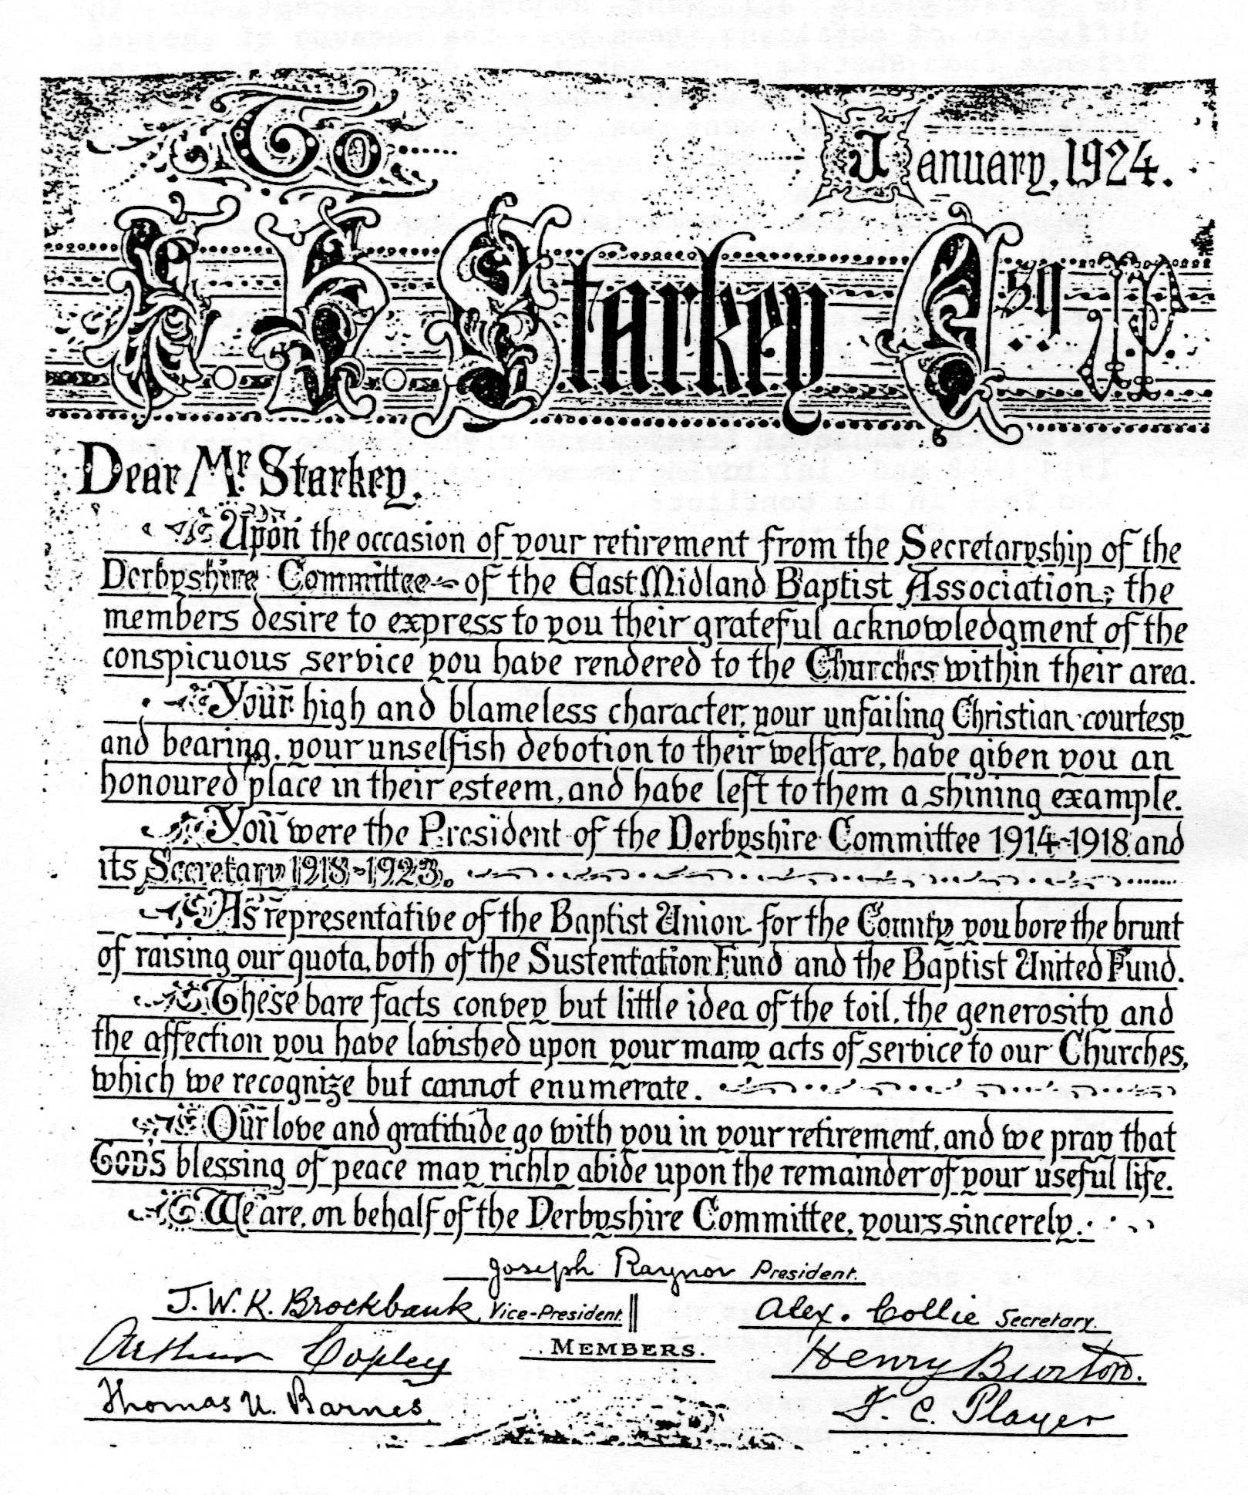
The major project undertaken by the church in 1919 was the restoration and enlargement of the organ. Mr. James Hatchett, the organist, outlined what work was needed and suggested many ways the £110 it would cost could be raised. A sale of work was held and several members subscribed to a fund, with the result that most of the money was raised. However when the work was finished the total bill came to £190 and a generous loan from a church member enabled it to be paid. The organ was reopened to the great satisfaction of organist and church alike.
The church continued its active involvement in the Denomination, holding special prayer meetings in November in response to an appeal from the E.M.B.A. There was also some discussion about whether to 'introduce copies of the Baptist Church Hymnal but no decision was made. The greatest involvement by the church in B.U. affairs was, of course, the work of Mr. Starkey and, in 1919, he became President of the E.M.B.A. Rev. Gray writes in the minute book:
"The church desires to put on record its sense of appreciation of the honours conferred upon its greatly esteemed secretary and senior deacon, John Henry Starkey:
By his accession to the Presidency of the E.M.B.A. in June 1919.
By his elevation to the magisterial bench.”
In connection with the former, the members desire that a copy of the Presidential address, which in their judgment contained a living message to the churches, be preserved in the church book. This resolution is in effect an expression of the deep love in which Mr. Starkey is held by all who are priveleged to work with him in Christian service".
(Unfortunately a copy of the address was not put into the church book!)
1920 was an uneventful year and appears to have been unfruitful spiritually, in spite of Mr. Gray's special evangelistic services. The usual services and special events were held and the choir gave a performance of Stainer's "The Crucifixion" for the church anniversary at Easter. There were three baptisms at Shottle during the year but none at Wirksworth. In August, the caretakers for 25 years, Mr. and Mrs. Wardman, retired. They were presented with a silver teapot at a special meeting.
In November 1920 came a letter of resignation from Mr. Gray. This appears to have followed a special meeting at which what amounted to a vote of ho confidence was passed. However, he was asked to stay on and in fact did not leave till 1922, so relations between him and the church must have been fairly cordial. It was an unproductive time though, with only a handful of people joining the church by transfer from other churches. Even so, the membership in 1921 was 107, which was more than during the war years.
A minor historical event took place in December 1921 when Mr. Gray attended a meeting in the Parish Church in connection with the League of Nations: "He placed his signature in the Parish Register, which has not been signed since the days of (Oliver) Cromwell by any non-conformist minister".
So the Grays left in 1922, and a short interregnum began. Fortunately the church was in a healthy state financially, recording a balance in hand, in 1923, of El. 10s.7d. The usual plans were made for pulpit supply and arrangements for the year's programme of events were made. Fortunately, no major decoration or repair work was needed, but it was discovered, after Mr. Henry Spencer was baptised, that the baptistry leaked. The church sought the advice of Mr. J. Spendlove, of Shottle, who recommended a lead lining; so this was installed.
In October 1923, a student, Mr. Samuel Collis, was invited to the church as student pastor, initially for one year. This was probably intended as an interim measure while the church looked for an experienced minister. However, Mr. Collis was greatly loved by the church and stayed until 1927.
The first two years of his ministry saw the resignation from office of some of the key church leaders. In December 1923, Mr. Hatchett resigned as organist and was presented with a silver tea and coffee set, (£10 having been collected by the church members). Many tributes to his skill were paid by the deacons and friends and it is recorded that "Mr. Hatchett replied in an admirable and feeling speech" and "Mr. Eric Land sang suitable music to the delight of the congregation".At the Annual meeting the following year, Mr. Samuel Land resigned after 15 years as treasurer, to be replaced by his son, Mr. Eric Land. But it was the resignation and later the death in 1924 of Mr. Starkey after 50 years as church secretary which really marked the end of an era for the church. He had become secretary in 1874, and so had been in a position of leadership throughout the most important years of the church's life. He had also played a large part in the life of the denomination and, as a mark of respect, the E.M.B.A. presented the church with an illuminated address placing on record their appreciation of his work and the inspiration of his Christian witness. The job of secretary was divided between Mr. Robert Johnston and Mr. Richard Taylor.
In April 1924, a baptismal service was held when Miss N. Barker was baptised, together with several people from Shottle. The Church at Bonsall was to be invited to this service, the first time Bonsall has been mentioned since their independence in 1897.
It was agreed later that year to sell the manse land. No plans had ever been made for building a house, so the church decided to sell it and reserve the money in a separate fund. Some of this money was used straight away to install electric blowers for the organ, following many complaints from Mr. Sam Gould, the organ blower, that it was hard work - even after the handle had been lengthened to provide more leverage.
Mr. Collis spent some of his time studying and twice put off taking his exams, on one occasion because he was ill and the other time because he was not sufficiently prepared! The church paid him an extra £5 for books to help him in his studies. He suffered a long illness early in 1927 and resigned in March, much to the regret of the church. He was presented with a gift of £20 as a "slight token of our esteem".

9. Years of Change : 1927-1943
After the difficulties and changes experienced by the church in the last few years, a lot of thought was given to the future. The Area Superintendent, Rev. Gummer-Butts, visited the deacons and one of his suggestions was that Wirksworth should once again join with Bonsall. This idea was not well received "because of the difficulty of supply. Also the question of the purchase of a manse made things difficult".
One of the problems the church faced was the increasing age of most of its members. Since the war, only a few younger people had joined the church and so most of the members were middle-aged or older. This is reflected in the numbers attending church meetings during these years. The annual meetings were the best attended, with about 30 members present, but at ordinary meetings the attendance was as low as 12. The membership was still in the region of 100, so these figures give an indication of the rather smaller number of active members. The Sunday School, too, had suffered a drop in numbers. In 1927, the E.M.B.A. wrote to the church about this, offering to help in any way they could.
After much thought and prayer, the church decided to seek a new minister, together with Shottle, and, in September 1927, they heard of a minister in Hayle, Cornwall, Rev. W.G.Bailey, who was looking for another church. Some of the Wirksworth people felt he would not want to come because it was too far, but he was invited and after a satisfactory meeting, he was invited to the pastorate for an initial period of four years. In spite of what had been said earlier in the year about the impossibility of buying a manse, the church decided to do so, and a house in Cromford Rd. was purchased for £500, ready for the Baileys to move into. They were welcomed warmly and their removal expenses of £33.15s were paid by the church.
One of the first things Mr. Bailey did was to revise the church roll. He visited all the members and asked those who had not been to church recently whether they wished to continue their membership. At a service in August 1928, a roll call of members was held and, the following year, Mr. Bailey started a new membership book, with a total of 75 members recorded by the end of 1929.
Regular reviews were made throughout his ministry.
Another innovation was made by Mr. Bailey. As a result of his pastoral visitation, he asked the church to start having an offering at communion services, the money to be used by him "to great effect among the poor". He was also keen to hold special evangelistic services and to introduce gospel solos after the sermon in some services.
1929 saw quite a few changes in the church. Mr. Samuel Land died and was greatly mourned by his friends in the church. In the autumn, his son resigned from the church as he was leaving Wirksworth. Heartfelt regret was expressed for "yet another break with a family whose name has been held in respect for many years". His place as treasurer was taken by his cousin, Mr. Thomas Land, and the new organist and choirmaster was Mr. Henry Snow, who was the headmaster of the Newbridge School.
For the next two years, the work of the church was uneventful, with only a few baptisms. Among those baptised were Mr. Arthur Deakin, his wife and his daughter, and Mrs. E. Southam. The usual events were held during the church year, with the choir under its new leader taking part in many of the special services. The choir, led by Mr. Snow, flourished at this time and enjoyed social activities and outings as well as the regular practices and performances.
The Sunday School began to increase its numbers and averaged 100 children. The Sunday School Anniversary was always one of the highlights of the year. A large platform was erected over the pulpit to seat all the children and the church was always packed. Chairs had to be arranged down the aisles and people stood at the back. (While the platform was in place, it provided a good opportunity for the caretaker, Mrs. Gould, and her family to clean the windows high up in the wall behind the pulpit!) During Wakes Week, in September, the Sunday School children took part in the Non-Conformist Sunday School parade round the town. Each Sunday School had a banner and the march was led by a band. Several hundred children from the Methodist, Congregational and Baptist Sunday Schools took part and the event finished with games and tea, with souvenir gifts of new pennies for all the children. (One lady, Miss. Marsh, from the Congregational Church, took part in the parade every year for more than 80 years.)
In 1931, there was a serious discussion about the Rev. Bailey's ministry. He was an elderly man, due for retirement, and some members hoped he would leave after his initial period of four years came to an end. He wanted to stay on, if the members wished, so a special meeting was held, presided over by another minister, at which the members voted. The result was 26 in favour of Mr. Bailey's staying on and 18 against. (Shottle voted 13 for, 1 against.) Mr. Bailey decided to stay, even with such a significant number voting against him. The rest of his ministry was an uneventful time. There were a few changes in the leadership, following the resignation of Mr. Thomas Land, who was moving to Nottingham. Mr. Richard Taylor became treasurer as well as secretary. Mrs. Hatchett was elected the first lady deacon and several more members of the Nalin family applied for membership: Mr. Geoff Malin, Miss Nancy and Miss Dorothy Malin.
Several people were baptised by Mr. Bailey in December 1934: Miss Phyllis Gould, Miss Marjorie Butlin, Miss Joan Halstead and Miss Mary Vallance. Also in 1934, the church lost two of its most active members. Mrs. Beeston died early in the year and was missed very much by her friends and fellow members of the church. She left a legacy of £50 and it was decided to use the money to install electric lights in the church. The work was carried out by Messrs. Taylor and Briggs of Derby and, after it was finished, a memorial plaque was erected behind the pulpit. Mrs. Beeston's daughter, Ida, (Mrs. Thompson), was living in Wirksworth at this time. She, too, was an active member of the church and there are several references in the minutes to her musical talents. She often sang solos at special events.
The other person who died was Mr. Richard Taylor, secretary and treasurer. A long obituary was written in the "Free Church Messenger", the Wirksworth non-conformist churches magazine. It begins:
"Surely the trumpets sounded on the other side when his soul entered into the life of the spirits around the Throne. Our sorrow is for ourselves and our joy is for him".
It continues with an account of his work in the church since the age of 16, and concludes:
"We shall miss him in the pulpit and the prayer meeting, where his voice was always heard in humble prayer and fervent praise; we shall miss him on the street, where his hearty hand-clasp and smiling interest in all that matters most helped many a weary soul along life's way".
He left a widow, a brother, Mr. John Taylor, and two nieces. Mrs. Hatchett became secretary in his place, with Mr. John Taylor as "temporary" treasurer.
After Mr. Bailey left in September 1935, the way forward for the church was not at all clear. With a smaller active membership at both Wirksworth and Shottle, there was considerable doubt about being able to support a minister. The Area Superintendent, Rev. C.H.Weaver, visited the church and discussed the matter at length. He encouraged the church to consider the possibility of forming a larger group to include the Duffield Baptist church, which was also fairly small. The members were undecided about this, voting in favour of it at one church meeting, but rescinding the decision at the next. The persuading factor was money, for Rev. Weaver made it clear that a grant would only be made available if the churches all agreed to the new grouping. So the church members agreed, rather reluctantly, to "fall in with the plan". It is clear that for many this was not the right way forward but, at the time, they could see no alternative.
In 1936, the church's Jubilee year, many important arrangements had to be made. In June, the Cromford Rd. manse was sold to Mr. H. Greatorex for £525 and the members who had loaned money when it was bought were repaid. A fund was started to raise money for a new manse and the church also decided to apply to a Building Society for a mortgage, if need be.
Mr. Weaver was a great help to the church during this year and, at the Jubilee Services in March, he preached at all the special services. Invitations were given to past members and friends and it was a time of joyful reunion for many. The aim was "to give thanks for the past and for all its wonderful history of God's goodness and grace, and to pray for the future of the church that it may be worthy of its great traditions".
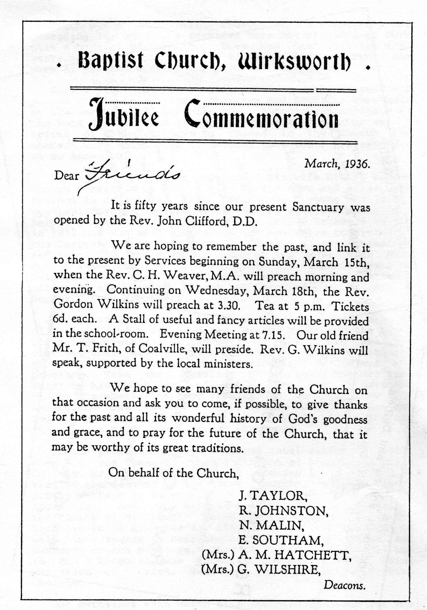
In July, Rev. J.C. Humphreys, co-pastor of a church in Cheltenham, came to preach at all three churches, and was unanimously invited to the pastorate. He agreed and was to begin in October. The first priority was to buy a house and a property on Derby Rd. was bought for £500. (There appears to have been no discussion about the location of the manse - it was assumed by all that the minister would live in Wirksworth.) The money was raised by a loan from the Derbyshire Building Society and smaller loans from members. Trustees were appointed to look after manse affairs.
Rev. Humphreys and his wife were very appreciative of the welcome given them by the church and they looked forward to a happy ministry. His recognition service was held in November and several speakers praised him as a "gifted preacher and devoted pastor".
So his ministry began, and was to last until the middle of the war, 1943. During these years, the church maintained its membership at about the same level,(around 70), although there were no baptisms and all the new members were transferred from other churches. There was a large number of deaths, 17 in all. However, the church was very lively and active, particularly in its social and fund-raising activities.
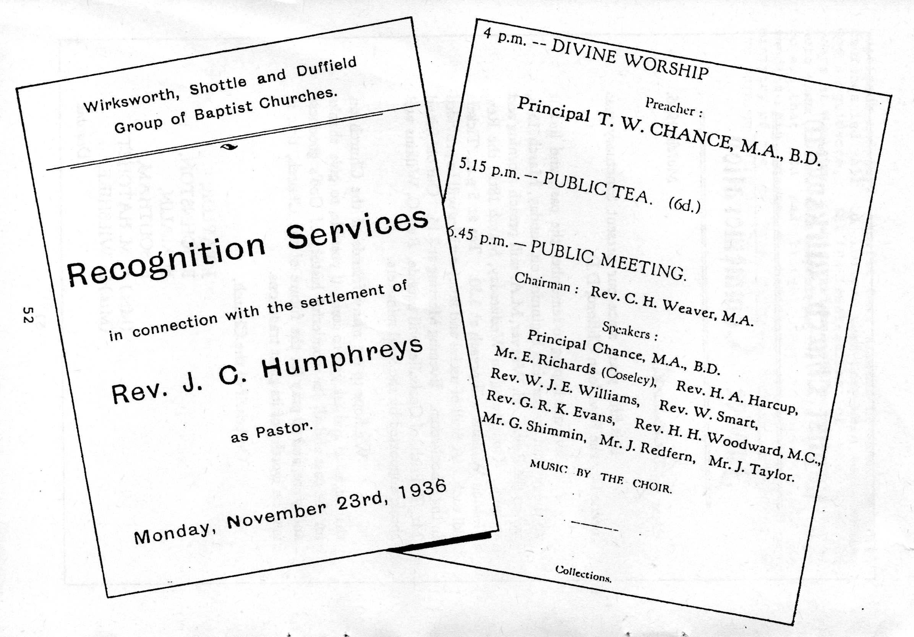
One happy occasion in 1937 was the Church Anniversary, which took the form of an "At home" to which many friends and past members were invited. Mrs. R. Taylor, as one of the oldest members, acted as hostess and, during the tea, several visitors spoke about their memories of the church. Mr. George Frith, a former member now living in Leicester, said he could never forget Wirksworth although he had left nearly 40 years ago. Mr. John Taylor was one of several older people who could remember the old church building. He recalled the numerous steps up to the door which he had had to climb as a small boy.
The following year, the anniversary took a completely different form, when the choir gave a performance of "The Holy City", complete with soloists and an orchestra.
Financial problems continued to worry the church and a lot of energy went into the annual sale of work held in the autumn. An attempt was made, in 1938, to restart an envelope scheme for collections but there was never enough money from this to meet all the financial needs. Another idea was to collect an additional Is per month from each member "towards helping finances at the end of the year" but again this was not enough to keep the church from a constant financial struggle. In 1939, at the Annual Meeting, Rev. Humphreys proposed that the church at Duffield should become part owners of the manse. They would pay a sum of £250 for a half share in the property. This was agreed to and, later in the year, all the arrangements were completed, including inviting the E.M.B.A. to become trustees of the manse.
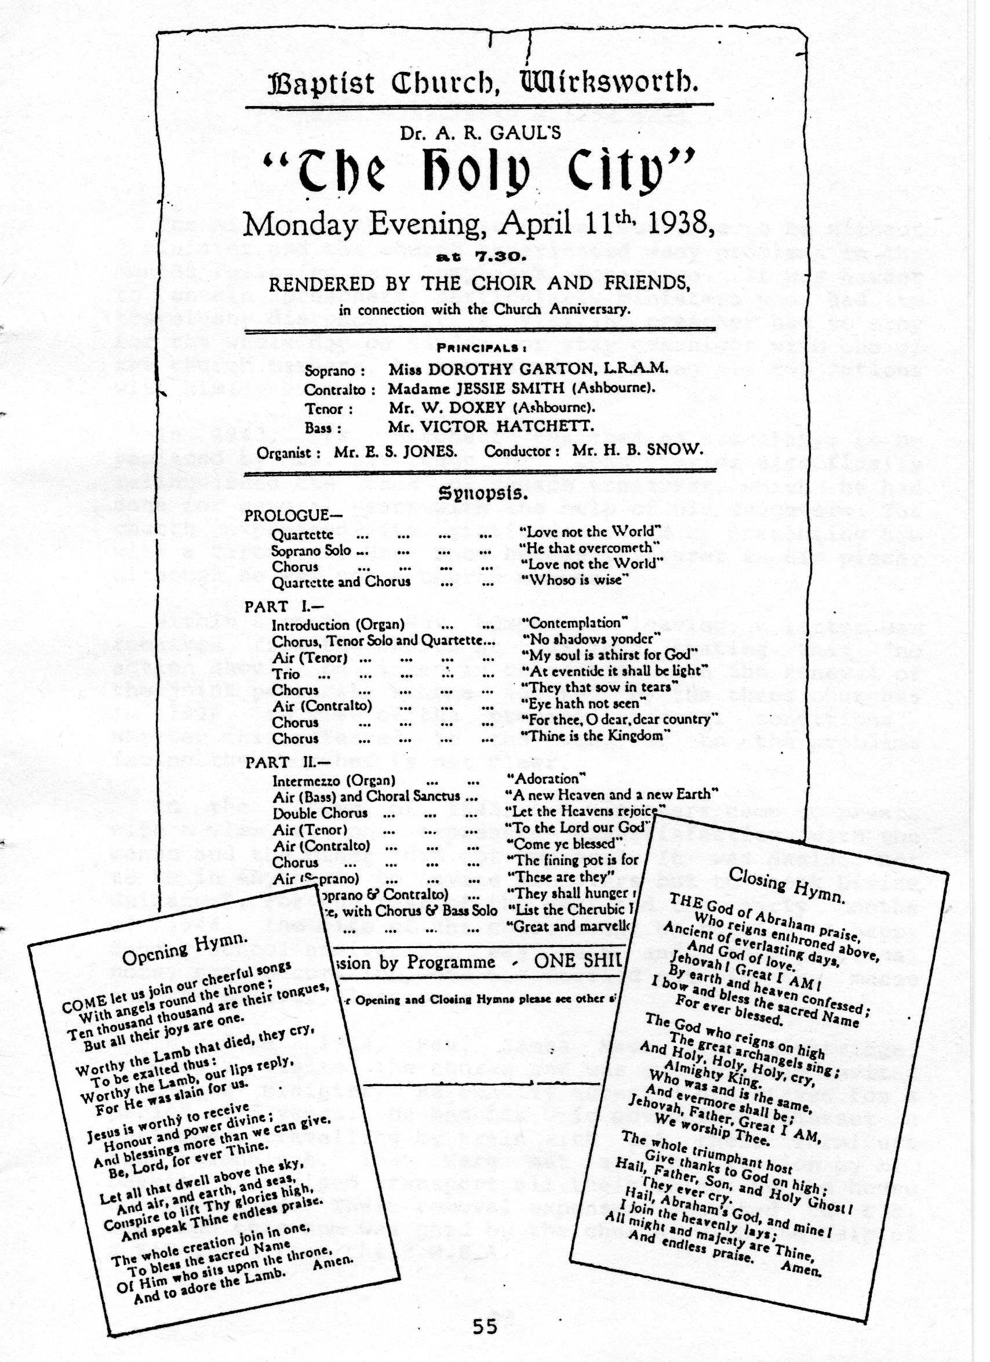
There are no recorded details of the way the group was organised or how Mr. Humphreys 'divided his time. It is clear that the Wirksworth church was the leader of the group, although both the other churches contributed to the minister's stipend.
The coming of the Second World War saw little change in the activities of the church. No members of the church were involved in active service, although younger members of their families and friends were. Services were held in the schoolroom from January 1940, to save coal and also to conform to the blackout regulations. The A.G.M. that year recorded the lowest ever attendance at a church meeting , 11 members only "braving the bad night .with heavy snow". The church started a collection of 1d a week from each member for the Red Cross and, in 1941, the Free Church Council began a canteen for soldiers in the Baptist schoolroom. Two deaths were recorded in 1940, those of Mrs. Butlin and Miss. Malin. Of Mrs. Butlin it was written: "We miss her ready laugh and happy word, and pray that God will bless her husband to whom she was so devotedly attached." Miss Malin's obituary reads: "Her church was her life, and for that she gave herself freely, unstintingly, gladly, lovingly. Her work as Sunday School teacher for 50 years will never be forgotten, and the boys and girls who have passed" through her hands will never forget the influence of her life and example."
Two years previously, Mr. Robert Johnston had died. He was one of the longest serving members and the church put on record "the incomparable loss it has sustained in the passing of our beloved deacon. He was a man of highest integrity, just and generous in all his doings, a friend loyal and true, a Christian gentleman."
1942 was a happy year for the church in many ways. A successful sale of work was held in the autumn and the members were so delighted with the result that they spontaneously sang the Doxology at the church meeting "as an expression of our gratitiude to God". A gift of £25 was given to the minister and his wife and several small loans from members were repaid. Earlier in the year, the church had been much encouraged by the transfer of membership of Mr. and Mrs. Liversage from a .church in Birmingham. The minute book records: "Our minister and several friends spoke kindly words of welcome and gratitude to God who we believe has answered our prayers for those who will be a strength and help to our church." Both Mr. and Mrs. Liversage had served as elders in their previous church, and Mrs. Liversage was the daughter of Rev. Isaac Ward, former minister of the church.
In 1943, Rev. Humphreys left for a pastorate in Crawley. The church members were sad at his going, and he was assured of the continued prayers of the church in his new sphere of labour.

10. Difficult Years : 1943-1951
The middle of the war was not a good time to be without a minister and the church experienced many problems in the months following Rev. Humphreys' departure. It was harder to obtain preachers, particularly ministers who had to travel any distance. If a visiting preacher had to stay for the whole day on Sunday or stay overnight with one of the church members, he was asked to bring his own rations with him!
In 1943, Mrs. Hatchett resigned as secretary: to be replaced by Mrs. Liversage. Mr. John Taylor also finally relinquished the task of church treasurer, which he had done for several years with the help of his daughters. The church expressed its gratitude to him by presenting him with a barometer. Mr. Snow became treasurer in his place, although he was not a church member.
Within a month of Rev. Humphreys leaving, a letter was received from the church at Duffield stating that "no action should be taken in connection with the renewal of the joint pastorate scheme adopted by the three churches in 1936, in view of the present abnormal conditions". Whether this referred to the war, or to the problems facing the churches is not clear.
In the autumn of 1943, two ministers came to preach with a view, but one expressed dissatisfaction with the manse and the other "did not impress". It was decided not to be in any hurry to invite ministers but to "seek Divine Guidance". For the rest of the year and the early months of 1944, the life of the church went on quietly. A happy Sunday School anniversary was held and, on a practical note, some decoration work was carried out in the manse and the smaller classrooms.
In June 1944, Rev. James Meek from Highbridge, Somerset, visited the church and was subsequently invited to become minister. He readily accepted and stayed for a period of 5 years. He and his wife moved from Somerset in September, "travelling by train with all their furniture and belongings. They were met at the station by Mr. Deakin, who helped transport all their things to the house on Derby Rd. Their removal expenses amounted to £38.10s, and this sum was paid by the church, with the help of a £10 grant from the E.M.B.A.
They were warmly welcomed by the church members but the ministry was full of difficulties from the start. This was partly due to the political situation in the last months of the war and the immediate post-war period. It was a time of unrest, shortages and political instability. All the major denominations were to experience a drastic reduction in members on a larger scale than at the end of the First World War. This decline continued until the 1970s, when some parts of the Church began to grow again. In Wirksworth, the next decade was to see the church membership reduced by two thirds, with the active membership becoming as low as 20. It was a very difficult climate in which to start a ministry and there were particular problems which faced the members and minister from 1944 onwards.
Because the church at Duffield no longer shared a minister with Wirksworth and Shottle, they wished to withdraw their half share of the manse. This was not an easy problem to resolve, and it would be true to say that it occupied the minds and drained the resources of many of the leaders of both churches for the next two years. It dominated the life of the church to such an extent that little progress could be made in any other area and, late in 1946, Rev. Meek resigned. He had been ill and in his letter of resignation said that he "found the place trying to his health". He moved to Leicestershire, to the joint pastorate of Cosby and Sutton-in-the-Elms, from where he retired after a few years. The people at Wirksworth were very sad at his leaving. He was regarded by them as "an inspiring preacher and a constant visitor to those in trouble". Mr. Snow writes:
"The spiritual work of the church has been carried on in the face of great difficulties and a high level of worship has been maintained by the minister. His removal has taken place without the least sign of anything but good Christian feeling".
After he left, in January 1947, the church was at a very low ebb. There was a grave shortage of money so that only £20 could be budgeted for the redecoration of the schoolroom. The church allowed the local Freemasons to use the schoolroom, and in fact they contributed toward the redecoration costs. The Annual Meeting had to be postponed once because of the extremely cold weather and, when it was held, only 9 members were present. Mrs. Liversage recorded in the minutes that "the present state of the church gives room for very serious thought on the part of all members. If the church is to continue to exist an earnest effort will have to be made".
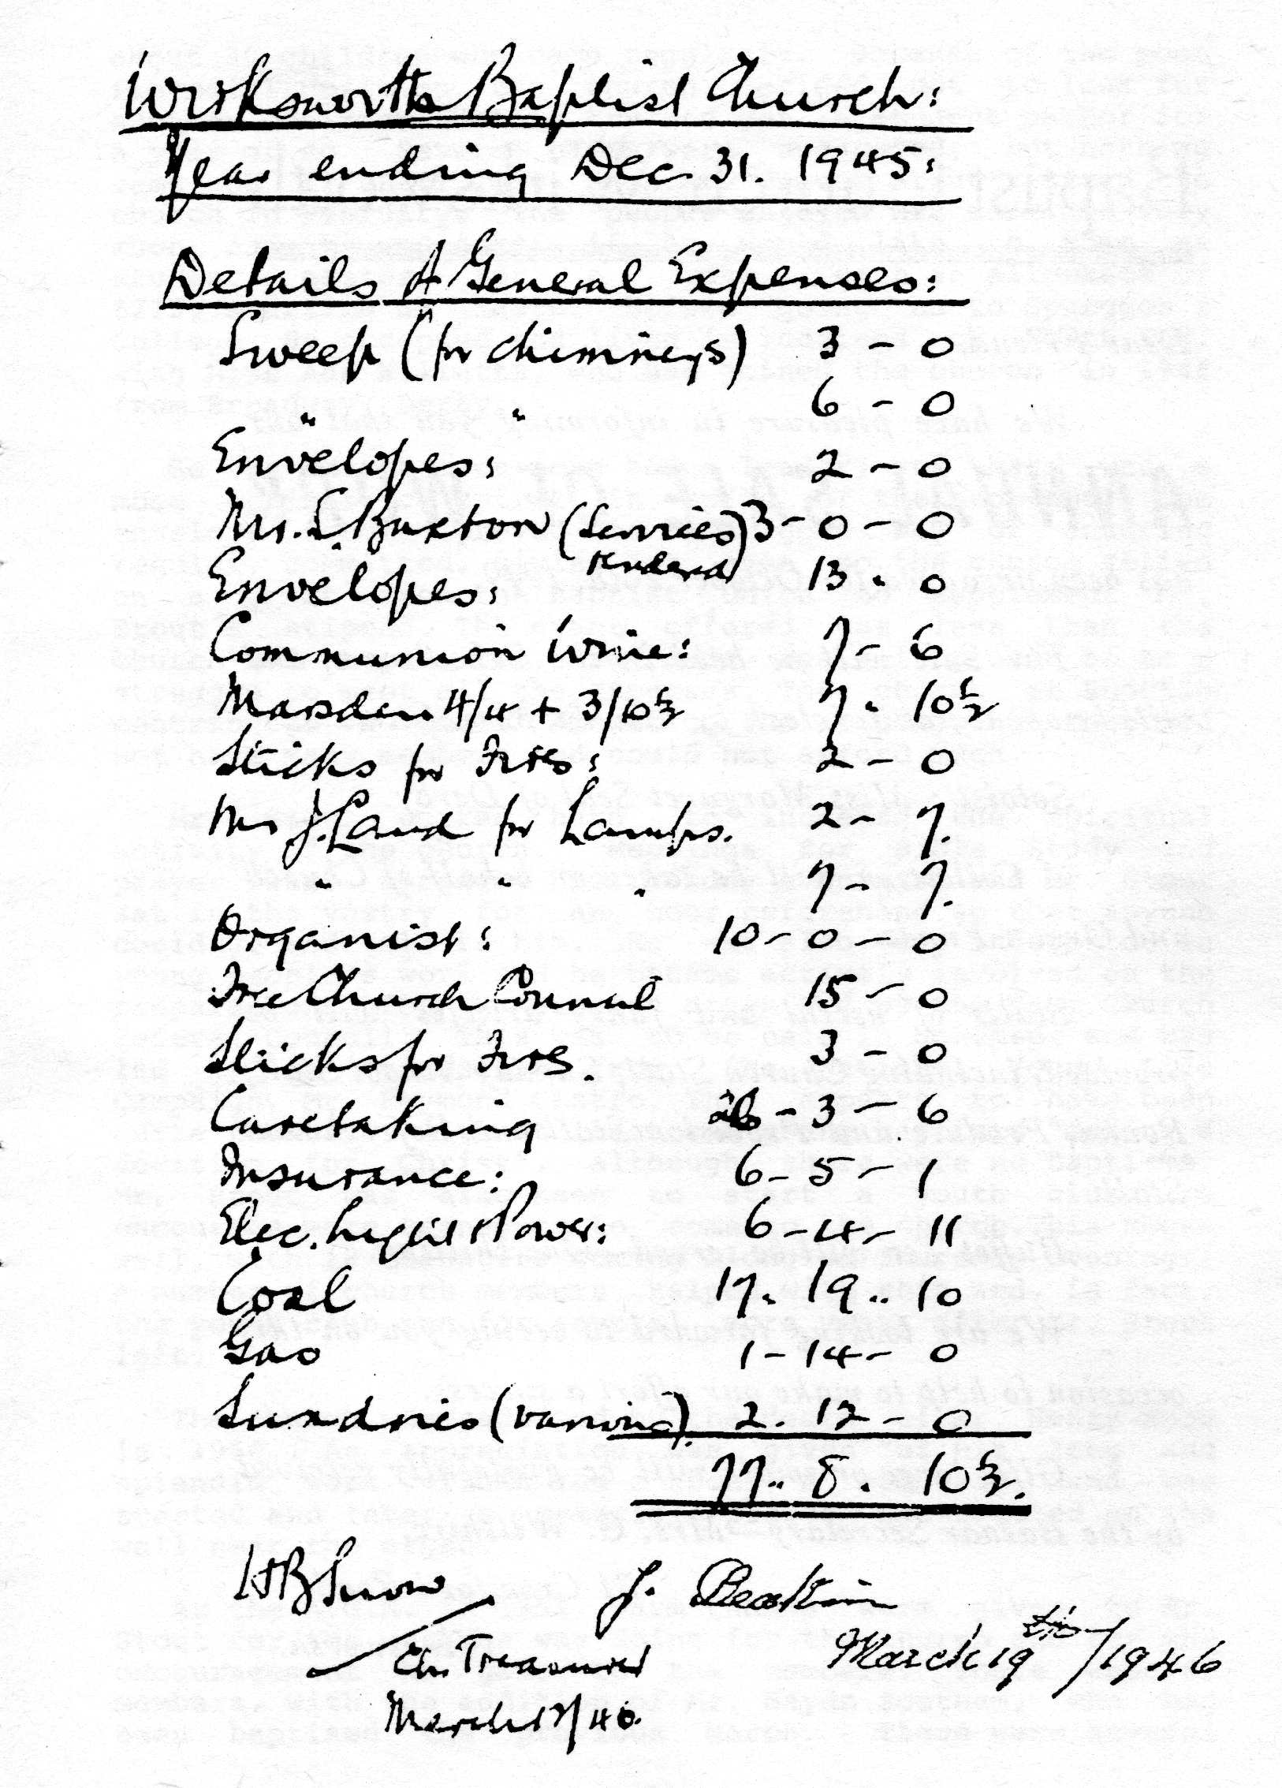
During the following year a nucleus of about 25 attended services very faithfully. The Sunday School had about 30 children who came regularly. Because of the poor financial position, the church decided not to look for another minister, but to try and get a student pastor for a year or so Several names were suggested, but nothing came of it until 1950, when Mr. Trevor Stout visited the church in February. The people enjoyed his services very much and he was asked if he would like to come as student pastor for a year, with an allowance of £210, starting at Easter before going on to Spurgeon's College. He accepted and lived in lodgings on North End, with Miss Ada Willetts, who had joined the church in 1946 from Broadway, Derby.
So the church once more had a leader; and there was a more optimistic spirit in spite of the problems. The envelope scheme proved to be a good way of ensuring regular, committed, giving but even so the church relied on a grant from the Baptist Union to supplement Mr. Stout's stipend. The grant offered was less than the church had hoped for, so once again it proved to be a struggle to meet all the expenses. The church at Shottle-contributed a small amount to the stipend, but they did not have many members and could not afford much.
Mr. Stout worked hard to increase the spiritual activity of the' church. Meetings for Bible Study and prayer were arranged for Monday evenings, and Mr. Stout sat in the vestry for an hour beforehand so that anyone could go and talk to him. He was also very interested in young people's work and he became actively involved on the preparations for a mission organised by the Free Church Federal Council. This was to be held in November and was led by an evangelist from the National Young Life Campaign, Mr. Raymond Castro. This appears to have been quite fruitful, with at least two young baptists "making a decision for Christ", although there were no baptisms. Mr. Stout was also keen to start a youth club, to encourage more teenagers to come to the church. This began well, with 18 teenagers coming along on Thursday evenings. A number of church members helped with this and, in fact, the youth club ran for several more years after Mr. Stout left.
The church was saddened by the death of Mr. Henry Snow in 1950. An appreciation was given "of his long and splendid work within the church". A memorial fund was started and later a memorial plaque was erected on the wall near the organ.
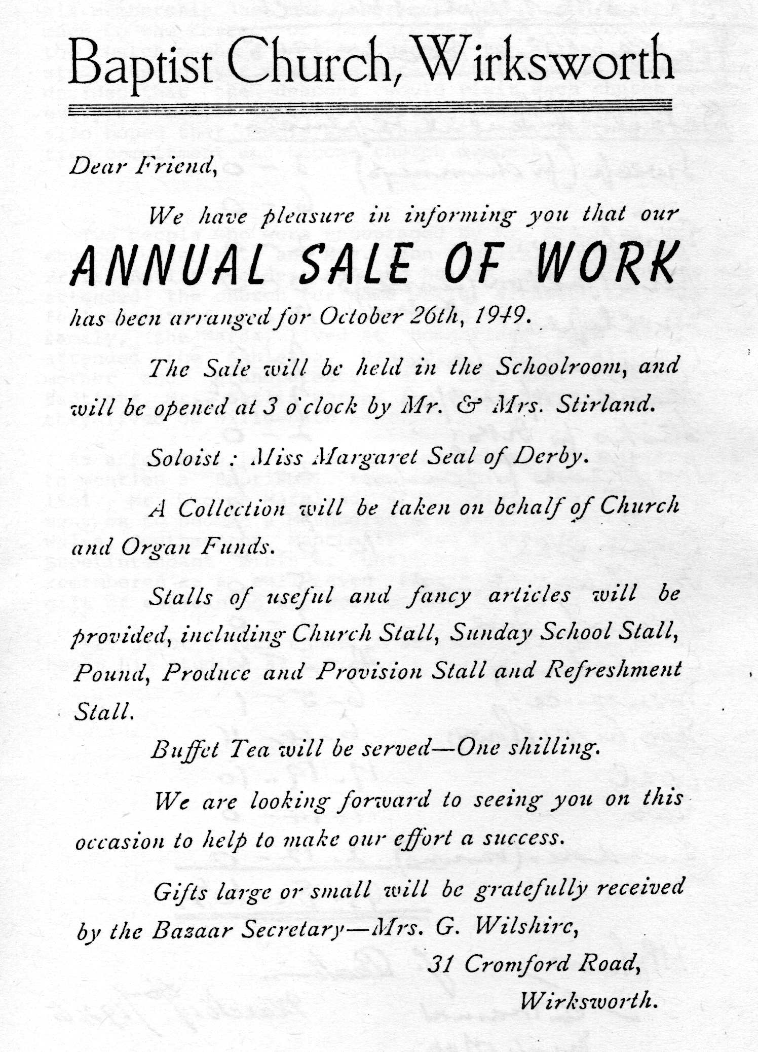
At the A.G.M. in 1951, warm thanks were given to Mr. Stout for the work he was doing for the church and for' the encouragement he gave to the members. There were 47 members, with the addition of Mr. Haydn Southam, who had been baptised the previous March. There were several losses too, including Mr. Ernest Butlin who transferred his membership to the Congregational Church during 1950, much to the regret of his friends in the church. All the church members were encouraged to attend the Bible study and prayer meetings more faithfully and it was also decided that the deacons would visit each church member every six months to offer encouragement and support. They also hoped that people who came to services would make a firm commitment and become church members.

Two people who were encouraged by Mr. Stout to join the church were Mr. and Mrs. John Butlin. John was Mr. Ernest Butlin's eldest son and he and his wife Joyce had attended the church for some while, although they did not feel committed to it until asked by Mr. Stout. Joyce's family, the Wards, lived at Homebridge Farm and Joyce attended the Ashleyhay Methodist church although her mother and grandparents Mr. and Mrs. Matkin, were Baptists. Mr. Butlin worked for Rolls Royce in Derby, and they lived on Willowbath Lane.
( As a footnote to Mr. Stout's ministry, it is interesting to mention a Baptismal service which took place in June 1951. Mr. George Marsland, a Methodist, was baptised and went on to become a Methodist minister. He served in South Wales, Southampton, Manchester and Pickering, where he was Superintendant minister until his death in 1974. He is remembered as a well-loved charismatic man, who had the gift of explaining the Word of God in simple language.)
Mr. Stout's year ended in September 1951 and he left to begin his studies at Spurgeon's College.

11. The Long Interregnum : 1951-1973
The longest period without a minister in the Church's history began when Mr. Stout left in 1951, and it lasted until. 1973. It was a difficult time for the members and at times many were discouraged, but they remained faithful to God throughout.
There were some changes early on when several members left the district. These included Mrs. Liversage who had served as secretary for a number of years. She was succeeded by Mr. John Butlin. Mr. Robert Durose, who was a member of the Shottle church, became organist, resolving the problem which had remained since Mr. Snow's death. The organ itself was finally renovated and repaired and in February 1953 was used again in services for the first time in five years.
The Sunday School superintendant, Mr. Deakin, and his wife also resigned; and among those who offered help in the Sunday School were Mr. and Mrs. Butlin and Miss V. Marsh.
One of the oldest members, Mr. John Taylor, died during 1953 at the age of 90. A memorial service was held later to dedicate a new communion table in his memory. His death represented another break with the past as he and his parents and grandparents had been keen and faithful workers in the church all their lives. He was survived by his two daughters who continued to support the church until their deaths in 1974 and 1980.
In 1954, further financial difficulties were experienced but during the next few years the church settled into a steady pattern of activity. Membership levels were maintained and a constant number of children attended Sunday School. One service only was held each Sunday, and there was usually no difficulty in obtaining preachers. The financial situation started to improve with steady regular giving and the proceeds from the successful Sale of Work held each autumn. It was decided in 1957 to hold a Gift Day instead of a Sale and this became the practice from then on.
Upkeep of the premises was a major responsibility and during the decade a lot of work was carried out. The walls of the cemetery were repaired and the cemetery chapel also needed attention. However the church could not afford the cost of complete renovation and eventually the chapel fell into disuse. The cemetery itself, posed something of a problem from this time as the plan of the graves could not be found. Mr. Butlin undertook to compile a new one but this was not easy. The interior of the Church was completely redecorated in 1957, and there was some discussion about whether to paint out the illuminated scroll above the pulpit, but it was decided to renew it. A service of dedication following the redecoration was conducted by Dr. Speirs from Broadway Baptist Church, Derby.
There were many discussions during these years about the ministry and various suggestions were put forward. One of the most important of these came in 1957 when Rev. Arthur Bonser, minister of Osmaston Road Church in Derby, proposed a scheme whereby the Wirksworth Church would receive help from members of the Osmaston Road Church. It was suggested that three lay-preachers from Osmaston Road would take regular services and help with the Sunday School. Rev. Bonser would chair members meetings and conduct special services. He was also willing to undertake pastoral and hospital visiting. It was envisaged that in time one " of the lay-preachers might become lay-pastor, but to start with there would be no financial commitment other than expenses.
These suggestions were discussed at length but eventually rejected. Those who supported .them were disappointed and felt that an opportunity had been missed. Others were unhappy with the idea of being linked with a much larger city church, and felt that the way forward was within a group of smaller churches as in the past.
In 1957, there were more changes in membership and responsibilities. Miss Marian Thompson returned to Wirksworth with her parents and became church secretary instead of Mr. Butlin. She and Mr. Butlin began to revise the church membership roll in 1957 and annually thereafter. In 1957 there were 29 members.
So the work of the church continued steadily and efficiently, but many of the members felt the need for more spiritual growth. During the next two years great efforts were made to deepen the spiritual life of the church. This applied to members personally as well as corporately, and in June 1958 several people made a deeper commitment to God in baptism. Rev. Arthur Bonser conducted the service and those baptised were Mr. and Mrs. Butlin, Miss- Thompson, Mr. Laurence Wain, Mr. Ken Southam, Mr. Cyril Thompson (Marian's brother) and Miss Val Marsh. Miss Marsh also became a church member at this time. She had started coming to church as a child when her aunt, Mrs. Southam, encouraged her to go to Sunday School. She was married later that year to Mr. Tom Ruddock who, some years later, took over one of- the town's two milk rounds, which he ran with his brother.
The Thompson family returned to Wirksworth when Mr. Thompson retired from the police force. Mrs. Thompson had always retained her membership at the Wirksworth church and she soon became actively involved in church life once more, as did her two children. The family lived on North End.
In -1958 an entirely new programme for mid-week meetings was started. This was called "Family Circle" and the meetings were to be held on Tuesdays. On the first and third Tuesday every month the Youth Club and Sewing circle would meet, concluding their meetings with an epilogue; on the second Tuesday there was to be a meeting with outside speakers; and on the fourth Tuesday the meeting would be more educational, with films or tapes. It was hoped that this variety . of meetings would attract everyone connected with the church. The scheme began well, but by 1960 was not so popular and was "giving cause for prayerful concern".
In 1959 Miss Myra Pegg joined the church. She, like Val Ruddock, had been encouraged by an aunt, Miss Dora Kay, to come first to Sunday School and then to church. It was sometimes more a matter of cajoling than encouraging, as Miss Kay would walk with Myra to the church steps and offer her the choice of going in with her or-waiting around with nothing to do until the service was over! Miss Pegg and Mrs. Ruddock were the only two young people to join the church out of all those who had gone to Sunday School with them. Many had left the town to go to college or to find a job, and others had drifted away. They and the handful of other young people in the church used to enjoy meeting after church on Sundays at John and Joyce Butlin's house.
Another problem with the building emerged at this time when it was discovered that the cellar was in a dangerous condition and needed major repairs. This was an expensive undertaking, but the work was carried out. In 1960, the cemetery again needed a lot of work, and Mrs. Thompson was appointed to be in charge of all matters concerning the cemetery. It was decided to hand over the Trusteeship of both the cemetery and the Church buildings to the Baptist Union, and to reassess the value of the property for insurance purposes.
At the start of 1960, it was again suggested that the church try to appoint a lay-pastor. Rev. Arthur Bonser continued to take an interest in this matter and he put forward several names but nothing came of it.
An attempt to restart the morning service was not successful, but instead a prayer meeting was held each Sunday at 10a.m. This was much appreciated by the small number of people who went. A time of prayer was also included at church business meetings. Many members believed that it was only through regular prayer that the church would be blessed and the way forward made clear. There was much to be thankful to God for during the next two years in spite of the problems. Numbers of active church members were small, reduced still further by the death in 1959 of Mr. Malin and Mrs. Wood, but services were well supported and the financial situation was good. The church took a full part in the Free Church Federal Council meetings and were blessed by visits from the Derby Youth For Christ choir and guest preachers for special events. The membership increased by two in 1961 when Mr. and Mrs. B Matthews moved" from Ripley. This was encouraging, but many members still felt the need for spiritual growth. The secretary wrote at the A.G.M. "We. need to seriously consider our task as a church, whether we are running on the right lines. There are tremendous opportunities awaiting us if we are all truly dedicated to the Lord and His service".

Miss Pegg and Mr. Roger Southam were baptised in 1961 by Rev. A.J. Symonds of Pear Tree Road Church, Derby, and later Miss Pegg became treasurer, with Mrs. Joyce Butlin as assistant treasurer. Miss Thompson left the church when she took up a teaching post in Oxford. She was heartily thanked by the church for "the most efficient and sincere way she has served the church in the capacity of secretary for.the last five years". Mr. John Butlin became church secretary again. The deacons at that time were Mrs. Wilshire, Mrs. Thompson, Mrs. Southam, Mr. Cyril Thompson, Miss Malin and Mr. Butlin.
The work of the church was encouraging during 1962 with the Youth Club, run by Mr. Roger- Southam, "meeting a real need". The Sunday School had a good year, and mid-week Bible Studies were held regularly. In the autumn the Baptist Union held its Tercentenary Celebrations' and the church loaned a copy of the church history written by Mr. Starkey in 1918 for the exhibition.
At the Annual Meeting in 1963, Mr. Butlin expressed his concern that the church was no nearer to having a resident minister. He felt that they all needed spiritual guidance and that little progress would be made in the life of the church without pastoral oversight. It was decided to write to the churches at Crich and Bonsai1 about the possibility -of sharing a minister. Nothing came of this and the following year another letter was sent out, this time to Shottle and Windley as well, but again no progress was made.
The church was saddened by the death of Mrs. Wilshire who at the age of 90 was the oldest member. She was a life deacon and had served the church faithfully for many years. On a happier note, Miss Pegg was married to Mr. Garry Collis, at the end of 1962. Mr. Collis became a member of the church in 1967, and his practical gifts were much appreciated. Amongst the jobs he tackled were the railings outside the church, which he completely refurbished. Later, he installed gas fires in the smaller classrooms - much more convenient than coal fires!
In 1965, the subject of ministry was again raised and Mr. Butlin wrote to the Baptist Union to seek their advice and suggestions concerning the pastorate.
The membership was increased by two when Mr. and Mrs. Turner joined the church from Fishgate Baptist Church, Preston. Mrs. Val Ruddock became a deacon when Miss Malin resigned. Mr. Ken Southam moved to Alvaston in 1966. Gas-fired central heating was installed in the premises that year at a cost of over £700. This was a major undertaking for the church - the vote for it at the church meeting was by secret ballot - but it was to prove of immense benefit to the church.
The church celebrated its TerJubilee in '1968 with special anniversary services. It was hoped that the former minister, Rev. J. C. Humphreys, would lead the worship but unfortunately he was- unable to come. The Sunday services were led by Rev. C.L. Martin of Belper, and a service on Saturday was addressed by the Area Superintendant, Rev. W.J.Grant. Invitations were given to all past members and friends of the church and it was a very inspiring and successful weekend.
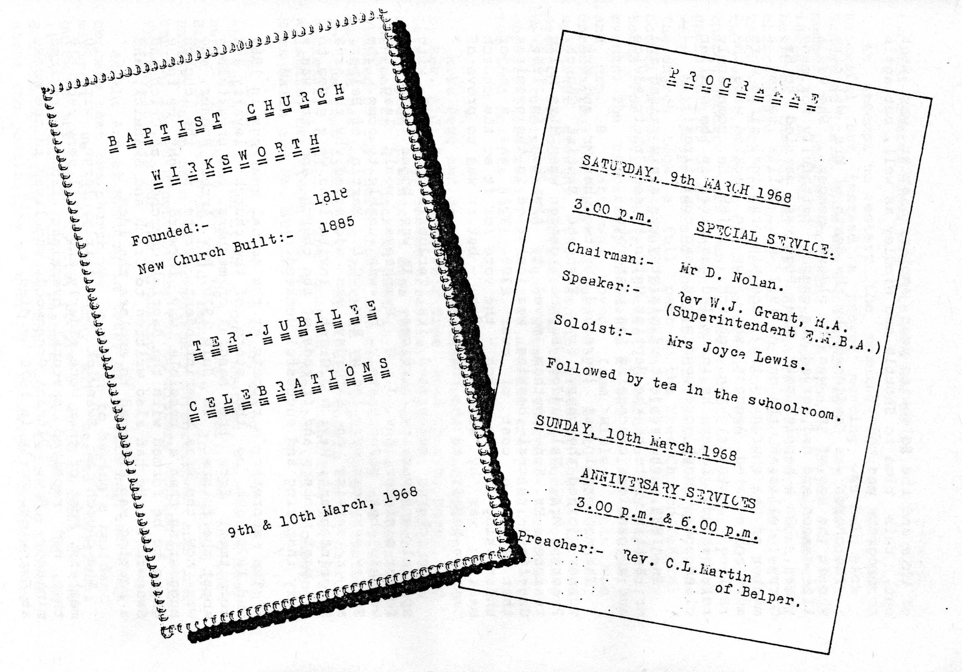
The secretary's reports at the annual meetings in 1969 and 1970 sum up the state of the church: loyalty and commitment from the handful of members, but uncertainty about the future. In July 1970, Rev. Arthur Bonser, who was now the Area Superintendent, wrote to the church suggesting that a possible way forward might be for a group to be formed with the Baptist churches at Crich and Swanwick. He had also written to Crich and Swanwick, and a meeting was arranged to explore the idea.
The church at Swanwick was fairly large, with 50 members. Most of them were elderly and until very recently they had received pastoral oversight from a retired minister, Rev. Vincent Greenwood, who lived in the manse at Swanwick. Early in 1970 he died.
Crich was a much smaller church, with a membership not exceeding 10, and their services were not attended by more than a handful of people. They had been assisted some years ago by the minister of Ripley Baptist Church, but were at present without any pastoral oversight.
During the next few months, the idea was discussed and prayed about in all three churches and meetings were held by the secretaries and deacons. Approaches were made to the Home Mission Fund about the possibility of a grant. A spirit of optimism began to spread in the church and members were encouraged to believe that their prayers were to be answered.
In 1971, Dr. Bryan Porter and his wife Hilary became church members. He was a G.P. in the town and Hilary was trained as a dentist. They had three young children, Deborah, Lyn and David. Bryan became a deacon and Hilary helped in the Sunday School. Mrs. Collis became a deacon in 1971 and was also elected to the executive committee of the Derbyshire Baptist Union. (There is an interesting reference to the accounts early in the year when Myra Collis asked for an extension of the financial year to coincide with the start of currency decimalisation.) Later in the year the church was honoured when Mr. Butlin became D.B.U. President.
During 1972, more meetings were held with the members of Swanwick amd Crich, and Rev. Bonser suggested the names of. suitable ministers. However it seemed to all the churches that, having made a decision to go ahead with the grouping, their plans were frustrated by delays and problems. This was puzzling at the time, but was seen later to have been part of God's plan, as it gave the church members the opportunity to get to know and understand one another. None of the three churches had had any previous connections with any of the others and the members were in many cases strangers.
So the patient waiting continued until early in 1973, when it was learned that a student at Northern Baptist College, Mr. Brian Nicholls, was looking for a church. He visited the deacons of the three churches during a foggy, frosty weekend in February. He was invited to preach on April 1st, and at a meeting held the following evening, the church at Wirksworth voted unanimously to invite Mr. Nicholls to be minister for the Group. They then had to wait in suspense to hear the outcome of the Crich and Swanwick church meetings. They too voted unanimously, and so Mr. Nicholls was formally invited to the joint pastorate of Crich, Swanwick and Wirksworth Baptist Churches.
The certainty with which this decision was made and the unanimous and joyful spirit that existed between the three churches led all to believe that they were experiencing God s guidance. All the frustrations of the past 20 years at Wirksworth, when various schemes came to nothing, were seen to be God's way of saying "wait". It was clear to all that God had brought them to this time and was-sending His choice of minister among them - for the ministry of the Rev. Brian Nicholls indeed proved to be the turning point in the life of the church.
12. The Church is reborn : 1973-1982
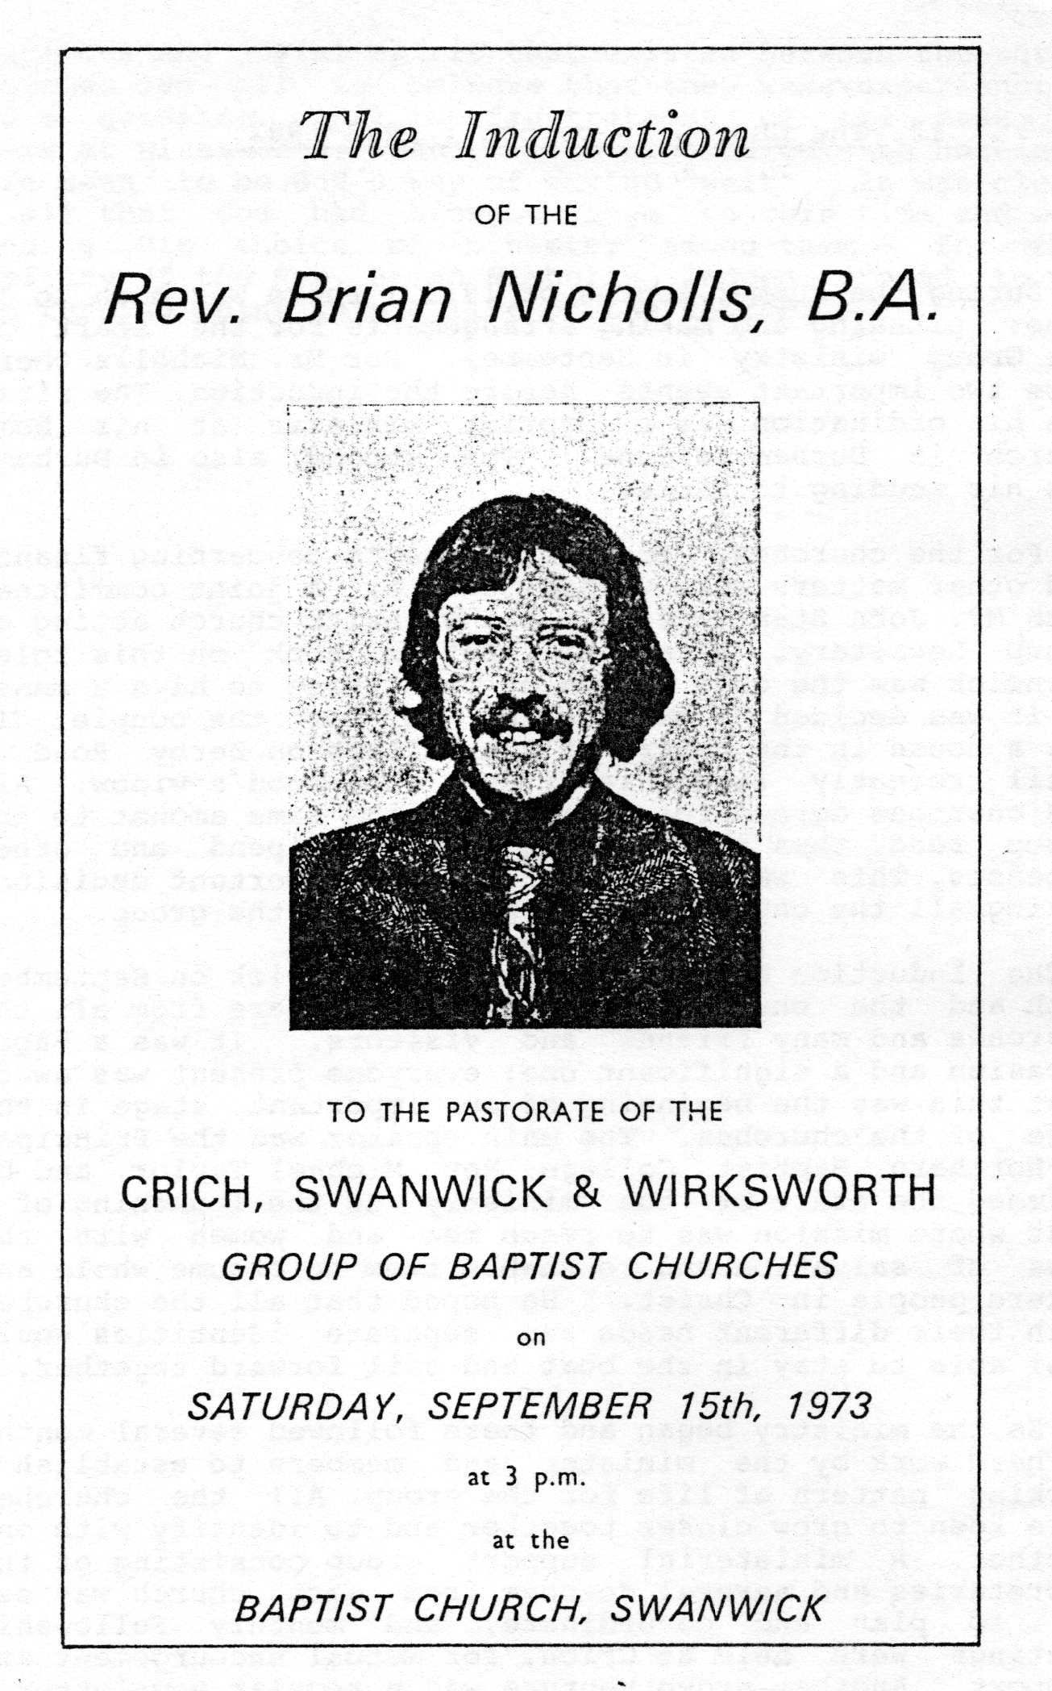
During the summer months of 1973, there was much to be done: planning and making arrangements for the start of the Group ministry in September. For Mr. Nicholls there were two important events before the induction. The first was his ordination as a Baptist minister at his home church in Durham in June. The second, also in Durham, was his wedding to Elsie.
For the churches, the arrangements concerning finance and other matters were worked out by a joint committee, with Mr. John Staniland from the Swanwick church acting as Group Secretary. Later Mr. Butlin took on this role. Swanwick was the only church of the three to have a manse so it was decided to make use of it for the couple. It was a house in the centre of the village on Derby Road until recently lived in by Rev. Greenwood's widow. All the churches agreed to contribute the same amount to the group fund, thus sharing equally the stipend and other expenses. This was felt to be an important decision, making all the churches equal partners in the group.
The Induction Service was held at Swanwick on September 15th and the church was packed with members from all the churches and many friends and visitors. It was a happy occasion and a significant one: everyone present was aware that this was the beginning of an important stage in the life of the churches. The main speaker was the Principal of Northern Baptist College, Rev. Michael Taylor, and he likened the start of the ministry to the launching of a boat whose mission was to reach men and women with the news of salvation and to enable- them to become whole and mature people in Christ. He hoped that all the churches with their different needs and separate identities would feel able to stay in the boat and sail forward together.
So the ministry began and there followed several months of hard work by the minister and members to establish a working pattern of life for the group. All the churches were keen to grow closer together and to identify with one another. A ministerial support group consisting of the secretaries and several deacons from each church was set up to plan and co-ordinate, and monthly Fellowship meetings were held at Crich, for mutual encouragement and support. Another group venture was a regular newsletter.
In Wirksworth, Mr. Nicholls had a very encouraging start when at his first church meeting there was an application for baptism from David Butlin, John and Joyce's son. He was baptised in October - the first of many baptisms for Mr. Nicholls.
During the next two years, the church began to grow and flourish, both numerically and spiritually. The members now had the leadership they had been lacking, and several attribute their own spiritual growth in Christ to the formation of the group and the ministry of Brian Nicholls.
As well as the monthly Group Fellowships, weekly meetings were held in each church. During 1975, each church studied the "Operation Agape" section of the "One Step Forward" programme produced by the Rev. Bryan Gilbert. These studies were very helpful as they challenged the church members to care for and love one another as brothers and sisters in Christ.
The church began thinking about stewarding and covenanting as a means of regular giving, and one of the Swanwick church members, Mr. Brian Randall, came to explain how the B.U. Covenant Scheme worked. He was well-qualified to talk on this subject as he worked for the Inland Revenue! The Randalls left the area for a year, living in Nottingham, but in 1976 they returned to Derbyshire and bought a house at Black Rocks. They transferred their membership to the Wirksworth church. They have two young sons, Richard and Michael.
Following discussions about evangelism and outreach, a 'Coffee for Shoppers' venture was begun. This was held on market days - Tuesdays - and the schoolroom was open for anyone to come in and have a cup of coffee and a rest for a very modest charge.
Mr. Nicholls was also keen to establish work among young people, and he was assisted initially by Mr. Ron Phillips and Mr. John Pearson. Ron was a member of the large Wirksworth Phillips family and was also related to Joyce Butlin. He had recently become a Christian, and was baptised in 1975. Mr. John Pearson and his wife Margaret joined the church in 1975, having previously worshipped at Cromford Methodist Church and before that at a Baptist church in Birmingham. They live on Summer Lane and have four children, Michael, Jenny, Sally and Richard.
At the A.G.M. in 1974, Mrs. Southam and Mrs. Thompson were elected Life Deacons. The membership was 21 and Mr. Butlin gave an enthusiastic and hopeful secretary's report.
During 1975, the church was redecorated and in August it was noted that the boiler in the cellar had suffered flood damage .The rains causing this followed a two month national drought.
There were several baptisms during the year including, in June, Mrs. Edith Spencer - a member of the United Reformed Church. Miss Daphne Smith was baptised and welcomed into membership later in the year.
In 1976 several members left the area: The Porter family moved to Cheshire - it was their house at Black Rocks .that the Randalls bought. Mr. Roger Southam moved to Chesterfield and his mother moved to Derby to live with her other son. There were also many newcomers including Mr. and Mrs. David Harvey, who moved from Derby, where they were members of the Broadway Baptist church. David worked in the County Council offices in Matlock and his wife Jean was taking time out from her teaching career to look after their two small daughters, Suzanne and Jenny. Another couple who joined the church were Mr. and Mrs. Alan Beech. They lived in Cromford near Ron Phillips and his wife Andrea. Their two children, Mark and Michelle, came to the Wirksworth Sunday School and soon Alan and his wife Pam came with them. In December they were baptised and joined the church. They started a Christian bookstall in the church which was very successful.
Mr. and Mrs. Brian Ashurst also became church members, having worshipped at the church for two years. They had originally moved to Wirksworth from Lancashire and lived on Summer Lane. They have one daughter, Lynne. Mrs. Hazel Ashurst is a doctor, working in Community Medicine in Chesterfield. Mr. Ashurst gave up his job to enable his wife to pursue her career full-time. He is actively involved in local politics and is a town councillor.
In January 1977, a morning family service was begun to coincide with Sunday School and to encourage parents to stay rather than leaving their children. Brian Randall became Sunday School Superintendent and was also elected a deacon at the 1977 Annual Meeting.
A sad event early in 1977 was the sudden death of Mr. Tom Ruddock, Val's husband. He was not a church member but was a regular worshipper and was a friend of many in the church. It was a time of great sadness for Val and her two young children, Keith and Joanne. Later, some hymn books were purchased by the family as a memorial to Tom.
During 1977, the Wirksworth and District Fellowship of Churches was formed. Discussions were held over a number of months concerning the future of the Free Church Federal Council and it was felt that there should be an organisation which included all the church groups in the area and not just the "Free" churches. A committee was formed with representatives from all the churches in the town, and a service of dedication was planned for December when the Bishop of Derby was invited to be the main speaker. Mr. Ashurst and Mr. Collis were the Baptist representatives on the committee.
The church continued to grow, with many people attending services and numbers in the Sunday School increasing. There was a desire to deepen the fellowship within the church and also to reach out to people in the town. .One idea which was tried was a Sunday early morning Communion Service followed by breakfast. This was a great success and so these Family Breakfasts became a feature of the life of the church.
The work amongst young people also flourished and there was now a Sunday evening after-church meeting, known as Buzz. This was run by Alan and Pam Beech. In the summer, Mr. Harvey suggested starting a Young People's Christian Endeavour group, to meet mid-week. He had been involved in such a group at his previous church, and he was on the National Committee of the Christian Endeavour organisation. This group was started in September with David and Jean Harvey, and Brian Randall as leaders. They were assisted by Mr. Roger Warne who was a neighbour of the Randalls at Black Rocks working for the Forestry Commission. He had recently become a Christian and was baptised in 1978.
At that baptismal service, Mr. Garry Collis was also baptised. Garry had been a member for some years, but felt the call to be baptised. Daphne Smith's mother, Mrs. G. Smith, was also baptised on the same occasion.
In the autumn of 1977, Mrs. Andrea Philips joined the church , transferring her membership from her home church at Pinxton. She was baptised at the same service as Mrs. Sue Gratton, who was Pam Beech's sister.
At the Annual Meeting in 1978, Mr. Butlin reported that the church's main problem was one of growth! There were 28 members and the Sunday School had nearly doubled in size. At the church party that year, Mr. Robert Durose was presented with a mantel clock and a gift token to mark 25 years as church organist. His musical talents were much appreciated by the church and congregation.
The rest of the year was dominated by two events: an evangelistic crusade in Derby and the re-roofing of the church. The Crusade was held in October and was led by evangelist Don Summers A visitation programme was drawn up and there were special pre-crusade meetings during the year. Many members of the church became actively involved in the preparations for the crusade: for some it was their first experience of this method of evangelism.
The problems regarding the church roof had begun several years earlier when it was noted that some of the slates were no longer water-tight. The cost of a new roof would be many thousands of pounds, so the first step was to ask the E.M.B.A. surveyor, Mr. Harold Rawson, to examine the whole building. He reported the church structurally sound and advised that the church obtain estimates for the roof. It was hoped that the church would qualify for grants from both the County Council and the Historic Buildings Trust. Because the church was within the Wirksworth Conservation Area, the reroofing had to be done with slates, not modern tiles. After much discussion and prayer and a lot of hard work, - particularly by Mr. Pearson as property steward - the decision was made to go ahead with the work using second-hand slates, at a cost of nearly £2,800. The work was completed during 1979.
Two more people were baptised in 1978: Lynne Ashurst, who had made a commitment to Christ during the year; and Jennie Pearson. They were both members of the Y.P.C.E. group. In July David Harvey outlined the need for a Junior C.E. group to encourage Sunday School children and their friends. This new group started in September, led by Jean Harvey, with as many as 26 children coming along. Ron and Andrea Phillips assisted.
Although the church was now in a healthy state financially, due in part to many people joining the Covenant Scheme, there had been many expenses arising out of the expansion of all departments. Copies of the 'Good News Bible' were purchased for use in church and by the Sunday School, and copies of 'Youth Praise' and other song books were also bought. Each church in the Group continued to contribute an equal amount to Group funds -although this amount had risen as costs increased. Wirksworth was by now the largest of the three churches and the group as a whole felt sufficiently confident to become financially independent of the Home Mission Fund.
The possibility of having a second minister in the Group was discussed seriously in 1979, having been broached originally a year earlier. The Wirksworth church particularly felt that they would benefit from the presence of a minister living "on the spot" instead of at the other end of the group. At first the idea was to invite a student, but after discussion with Rev. Arthur Bonser, they felt that a trained minister would serve their needs better. However, an alternative scheme was put to the churches for consideration: Northern Baptist College was introducing a new idea for training students for the ministry. This Alternative Pattern of Training (A.P.T.) would involve the student- in a church for half his time, with the rest of the time spent at college. In practice this would mean three days a week in Wirksworth and three at college during term time, and one day a week at college in the holidays. This idea was warmly received as it would not be such a financial burden for the Group and it would be an opportunity for the churches to help in the training of a minister.
The idea was adopted, and later in the year Mr. Brian Radcliffe visited the group to meet the deacons and members, and was unanimously invited to come as student minister for three years at the start of the college year.
The question of a house had to be sorted out quickly. The Group agreed that Mr. Radcliffe and his wife Sue should live in Wirksworth, so the church discussed what could be done. The Derby Road manse was still occupied by tenants who had expressed a desire to buy the house. The sale would take some time however as it involved the E.M.B.A. as trustees and also the Charity Commission. The church decided to look for somewhere to rent for the Radcliffes and several properties were looked at. However, none of them seemed suitable, and the church members were very unsure about the way forward. While they were thinking and praying about it, a house on Greenway Croft came on the market at a price the church could afford to pay, and this was seen as the answer to the need. The purchase went ahead swiftly and the Radcliffes were able to move in early in September.

Mr. Radcliffe was welcomed at a special service on September 8th and he began his college term shortly after. A support group, made up of members from all the churches, was formed to meet with and encourage him and to visit the college from time to time. He and his wife Sue were greatly appreciated by the people in the church - it was good to have a minister close at hand instead of a 20 minute drive away!
Another important development in 1979 concerned Mr. David Harvey. He was a gifted preacher and for some time had been thinking about the possibility of training for the ministry. After much thought and prayer, he felt that God was calling him to train as a supplementary minister. This involved a course of study at a college, leading to ordination, and a ministerial role within the church, while still continuing to go to work. This idea was brought to the church members at a special meeting where a resolution was passed supporting David's call and recognising its potential value to the church. He also received the support of the E.M.B.A., who provided a grant to help finance the course of study which he was to begin in the autumn at Northern Baptist College. Mr. Harvey handed over his leadership of Y.P.C.E. to Mr. Radcliffe in order to have time to study.
In June 1979, the E.M.B.A. Annual Assembly was held at Swanwick. Rev. Brian Nicholls was President that year and it was traditional for the Assembly to meet in the President's home church. The 120 delegates stretched the resources of the Swanwick kitchen considerably - but not the generosity or talent of the members: splendid meals were provided. Ladies from all the churches helped, with Miss Daphne Smith co-ordinating the work.
There were several enjoyable social events during the year, notably a camping weekend in August. Several such weekends were held during the summer at this time, but they were not always blessed with good weather. Rumour has it that on one occasion certain less hardy campers left their cold, damp, tent and sneaked back to the warmth of their own beds!
The Fellowship of Churches continued to organise and hold joint meetings and it was gratifying to see people from nearly every denomination supporting it. As well as joint services, the F.o.C. also enabled other organisations in the town such as the Christian Aid group and the Overseas Development group to increase their work and effectiveness. An exhibition was staged annually during One World Week, each year's being more challenging and worthwhile than the previous. The most successful joint meeting arranged by the F.o.C. are those held during Lent. They usually take the form of house groups for discussion and prayer and have proved to be very stimulating.
A very popular Children's Holiday Club was run during August 1979. All kinds of activities were laid on, including painting and sweet making, with games and stories too. Mrs. Harvey anticipated as many as 30 junior children would attend J.C.E. during the winter months.
A sad event in the early months of 1980 was the death of Miss Elizabeth Taylor, the last of her family. She had been a member of the church since 1916 when she was baptised by Rev. Isaac Ward.
1980 was a year for taking stock, after the rapid growth of the previous two years. One important decision concerned pastoral care. As well as the members of the church, there were many other people who had links with it and it was widely felt that there should be a structure within the church whereby all these people could be cared for. A day conference was held to consider this, and the idea for Care Groups was devised. These were organised on a geographical basis, with two leaders who were responsible for the people in their group. This involved visiting any who were old or in need and referring any special needs to the ministers.
Another group formed at this time was an informal 'Christian Basics' discussion group. This met a real need among the younger Christians in the church and it became known as the Cromford house group.
Mi's. Sue Radcliffe started a daytime fellowship for ladies at home and this met weekly, with several small children and babies going along too! Some of the mothers of older children felt the need to get together and pray for them, so a ladies prayer meeting was held monthly, specifically to pray for the teenagers within the church.
In the summer of 1980, the church at Bonsall made it known that they would be interested in joining the Group. They were welcomed by the other churches and they officially became part of the Group in the autumn. They were a small church, with a handful of members, and they held one service on a Sunday afternoon. Many lay preachers from the Group, as well as the ministers, enjoyed visiting the church and taking the services. The Bonsall church had been independent for just under 100 years, having left the Wirksworth and Shottle group in 1897.
Several more people joined the church during.1980. Mr. and Mrs. John Young and their two sons moved from Sheffield; and in July, the Cantwell family started coming to the church. Mrs. Kath Cantwell was baptised in December and her husband, Steve, became a member by profession of faith. However, he was later challenged by God to a deeper commitment and he too was baptised in 1981. They lived at this time in Matlock, having been put off Wirksworth after visiting it on a cold, rainy day! Later, they did move - to a house in Ladyflatts Road. They have one son, Ian.
In the autumn, the Lancaster family moved to Matlock from Mold, North Wales. Mr. David Lancaster works for the County Council in Matlock and he and his wife Ruth have four children: Stephen, Beverley, Ian and Rebekah. In their previous church in Wales, Mr. Lancaster had been a youth leader and, after a few months, he joined Brian Radcliffe as leader of Y.P.C.E.
In June 1981, Mr. and Mrs. Thompson celebrated their Golden Wedding and the church arranged a celebratory lunch for them.
An amusing incident occurred later in the summer when an open-air service was organised by the Fellowship of Churches on Bolehill. Unfortunately, the organisers had neglected to inform either the police or the Forest rangers of the event and, while Brian Nicholls was preaching, several policemen arrived on the scene. Mr. Nicholls could not see them and carried on preaching, while people tried to signal to him to stop!
In the autumn of 1981, an important discussion was held concerning the future of Brian Radcliffe, whose training ended the following year. The Northern Baptist College recommended that A.P.T.- students should leave their church after training and seek a full time post elsewhere. There were many people in the church and Group who wanted to invite Mr. Radcliffe to stay, and so the matter had to be discussed and voted on. It became clear that the majority felt he should abide by the college's recommendation and leave, so Mr. Radcliffe decided to make himself available for a call to another church. Early in 1982, he accepted an invitation from the Macclesfield Baptist Church to become their minster, starting in the autumn. This was a very difficult time for the churches in the Group, the most testing in their life together. Their loyalty and their faith in the guidance of God were both challenged.
After Mr. Radcliffe's decision to leave, the churches agreed that he should be replaced either by another student or by a full-time minister. All the Wirksworth members realised how much they would miss the pastoral ministry of both Brian and Sue Radcliffe. Rev. Arthur Bonser once again advised the Group and, after a lot of prayer and thought, it was agreed that Mr. David Harvey, following his ordination, should be officially inducted into the group, as supplementary minister for Wirksworth. Mr. Bonser suggested that the Group should think in terms of appointing another full-time minister, perhaps an evangelist, in two year's time.
However, these ideas had to be put to one side early the following year, when Rev. Brian Nicholls accepted an invitation from the Mansfield Road Church, in Nottingham, to become their minister, starting in May. He had been the minister of the Group for nearly nine years and had not been looking for a move, but he recognised the call of God to move to Nottingham. He wrote in the Newsletter:
"Yes, it's true. We really are leaving in the early summer. After nearly nine years of adjusting to village life, and Derbyshire hills, the Lord in His infinite wisdom called us to the big city with all its noise and dirt. We didn't want to go, but having always advocated that we must be obedient to God as Christians, we couldn't refuse to test the invitation which came out of the blue.
Please pray for us as we prepare to move .... and pray also concerning the appointment of a new pastor here: that he may be a man of faith, full of the Holy Spirit, Bible-believing and -preaching. One thing is certain: that if the Lord has called us away, He has other things lined up for the situation here in Derbyshire".
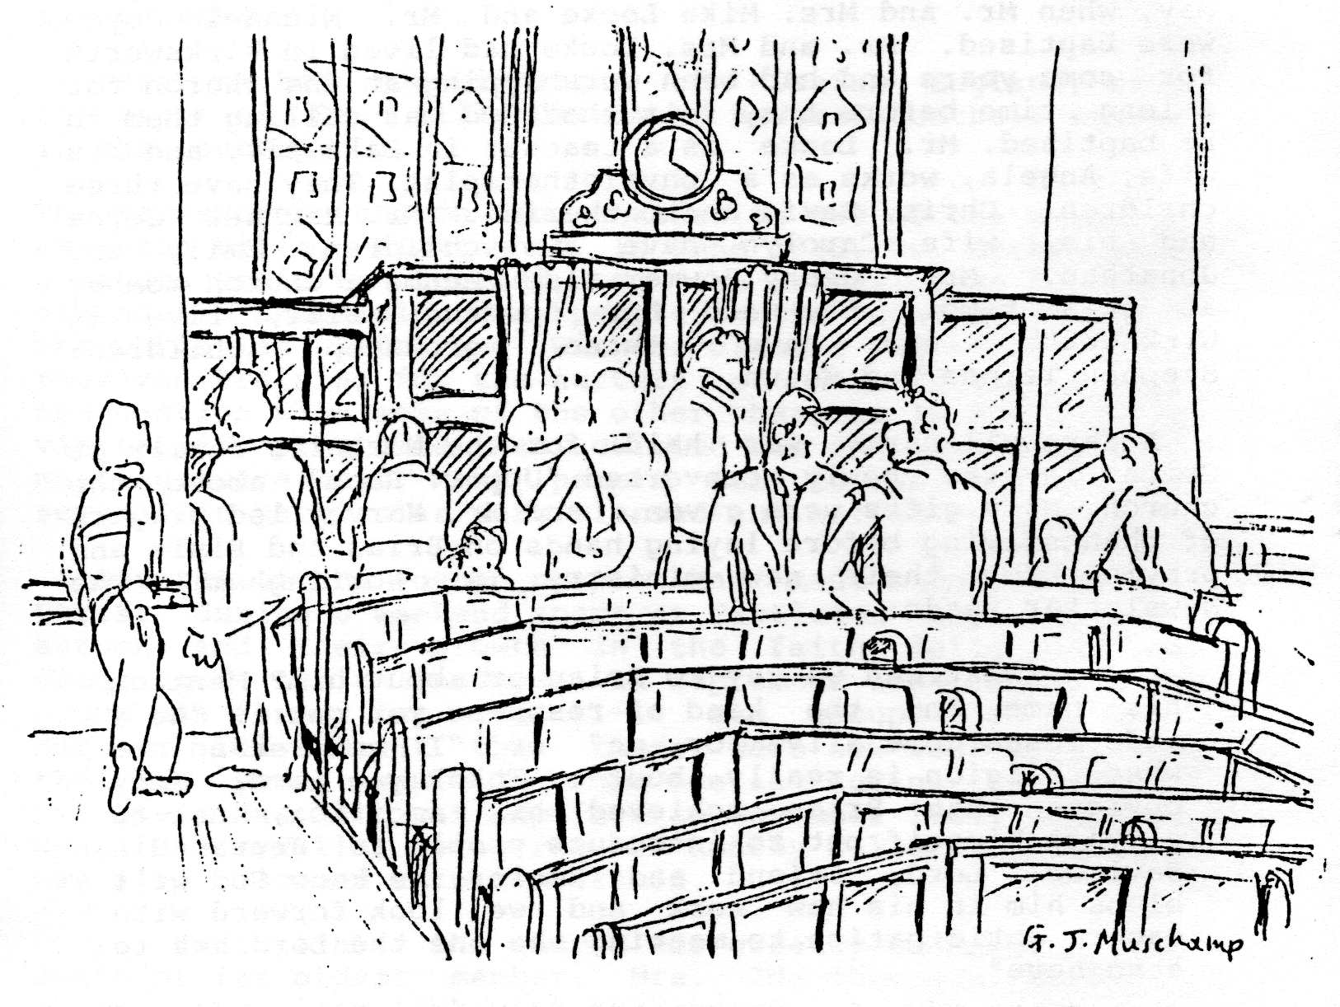
The church members were very sad at the prospect of losing Brian and Elsie Nicholls but accepted it and gave their blessing and support for their new ministry in Nottingham. Immediately, a Group committee was set up to negotiate with the Area Superintendent the appointment of a senior minister for the Group.
This news obviously over-shadowed everything else in the first half of 1982, but other things happened too! Several new members joined the church, including Mrs. Margaret Parsons. A baptismal service was held early in May, when Mr. and Mrs. Mike Locke and Mr. Michael Joyce were baptised. Mr. and Mrs. Locke had lived in Wirksworth for some years and had been worshipping at the church for a long time before they felt that God was calling them to be baptised. Mr. Locke is a teacher in Bakewell, and his wife, Angela,.works as a physiotherapist. They have three children: Chris, David and Catherine. Mr. Michael Joyce and his wife Carolyn have two children: Emily and Jonathan. Mrs. Jenny Bowmer also became a church member at this time. She and her husband, Bill, live in Wirksworth and have three grown-up children: Stephen,Teresa and Shaun.
A farewell party was held for the Nicholls family at Crich in the newly converted "Upper Room" above the church. Many gifts were given, and Mr. Harvey led prayers of thanksgiving before laying hands on Brian and Elsie and praying for their new ministry in Nottingham. The Newsletter reads:
"What can we say to Brian or about him? Mention his name and the kind of response you get is "He's made Jesus come alive for me" or "I understand now what religion is really about". Thank you Lord! It's obvious that Brian achieved his ambition, not to elevate himself but to introduce people to Jesus, His Saviour, Lord, Friend and Healer. We know God will bless him in his new work and we look forward with eager anticipation to meeting the one the Lord has to send here".
The induction service, at Mansfield Road Church, was held in May and many people from the Group went to it. As one person said "We knew he had really gone when we saw his name on another church notice board".
So his ministry came to an end with an element of understandable sadness, but mostly there was thankfulness to God for all that had been done since the Group was formed. "We were dying as a fellowship until Brian told us that Jesus is alive now. So is His church - and it's growing. Hallelujah!"

13. The Present and the Future : 1982 -
The Group did not have to wait long for an answer to their prayers for another minister, after Rev. Brian Nicholls left. In June, they heard about a minister in Eltham", London, who was looking for a rural church or group. Rev. Harry Godden had ministered before in a group of churches, in Bradford, before moving to Eltham. His wife, Frances, had recently completed training for the supplementary ministry at Spurgeon's College and they were hoping to be able to minister together. They visited the Group in June, with their teenage children: Richard, Pamela and Michael. They met the church members and preached in every church and, at a subsequent meeting, were invited by the Group to come as ministers, beginning in October.
Meanwhile, the Wirksworth church said goodbye to the Radcliffe family as they left for Macclesfield. They were sad to leave "the friendliness of Wirksworth and especially Greenway Croft" but they looked forward to their new pastorate.
Preparations were made for the arrival of the Goddens in the autumn. The Swanwick manse was sold, as was the house on Greenway Croft, and a new house on an estate outside Swanwick was bought.
The induction services were planned for October 23rd and it proved to be a very busy day! David Harvey was to be ordained and inducted at Wirksworth in the afternoon, and in the evening at Swanwick, Mr. Godden was to be inducted as senior minister to the Group and his wife ordained and inducted as Supplementary minister.
The service at Wirksworth for Rev. David Harvey was a happy and moving occasion: for David the culmination of several years of study and training and for the church the beginning of a different form of ministry. The service was led by Rev. Brian Nicholls, with Rev. Arthur Bonser and Christian Endeavour President, Rev. James Heron, also taking part. The main speaker was Rev. David Clark from Cardiff. He challenged the ministers and church to take hold of the authority given them by Jesus Christ.
The Town Hall was packed for the excellent tea which followed, and there then followed a mad dash by car over to Swanwick for the evening service. Rev. David Harvey conducted this service and the main speaker was an ex-President of the Baptist Union,- Mrs. Nell Alexander, who took as her theme "Go forth and tell".
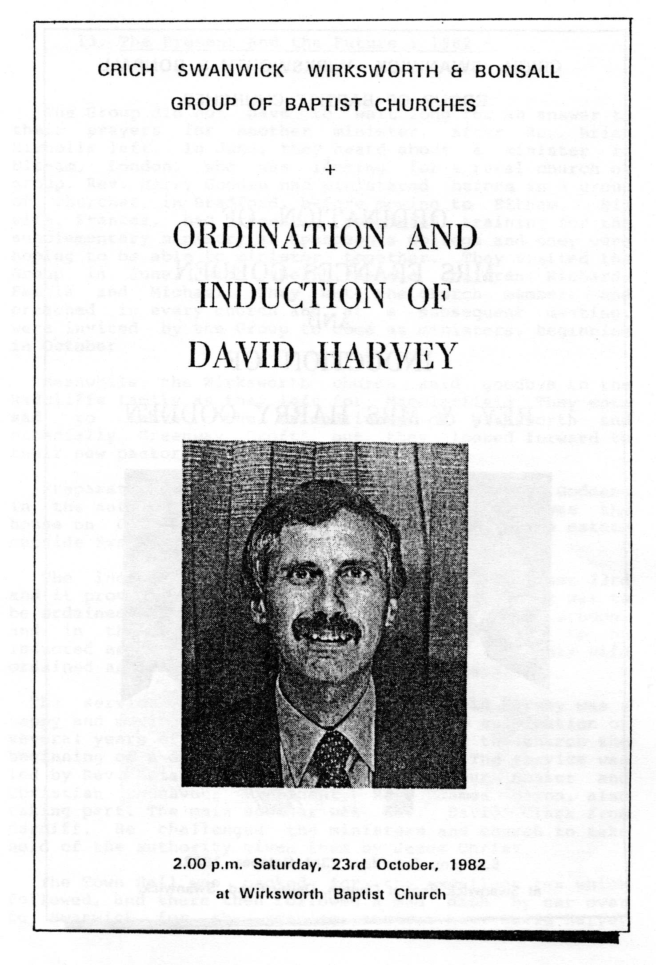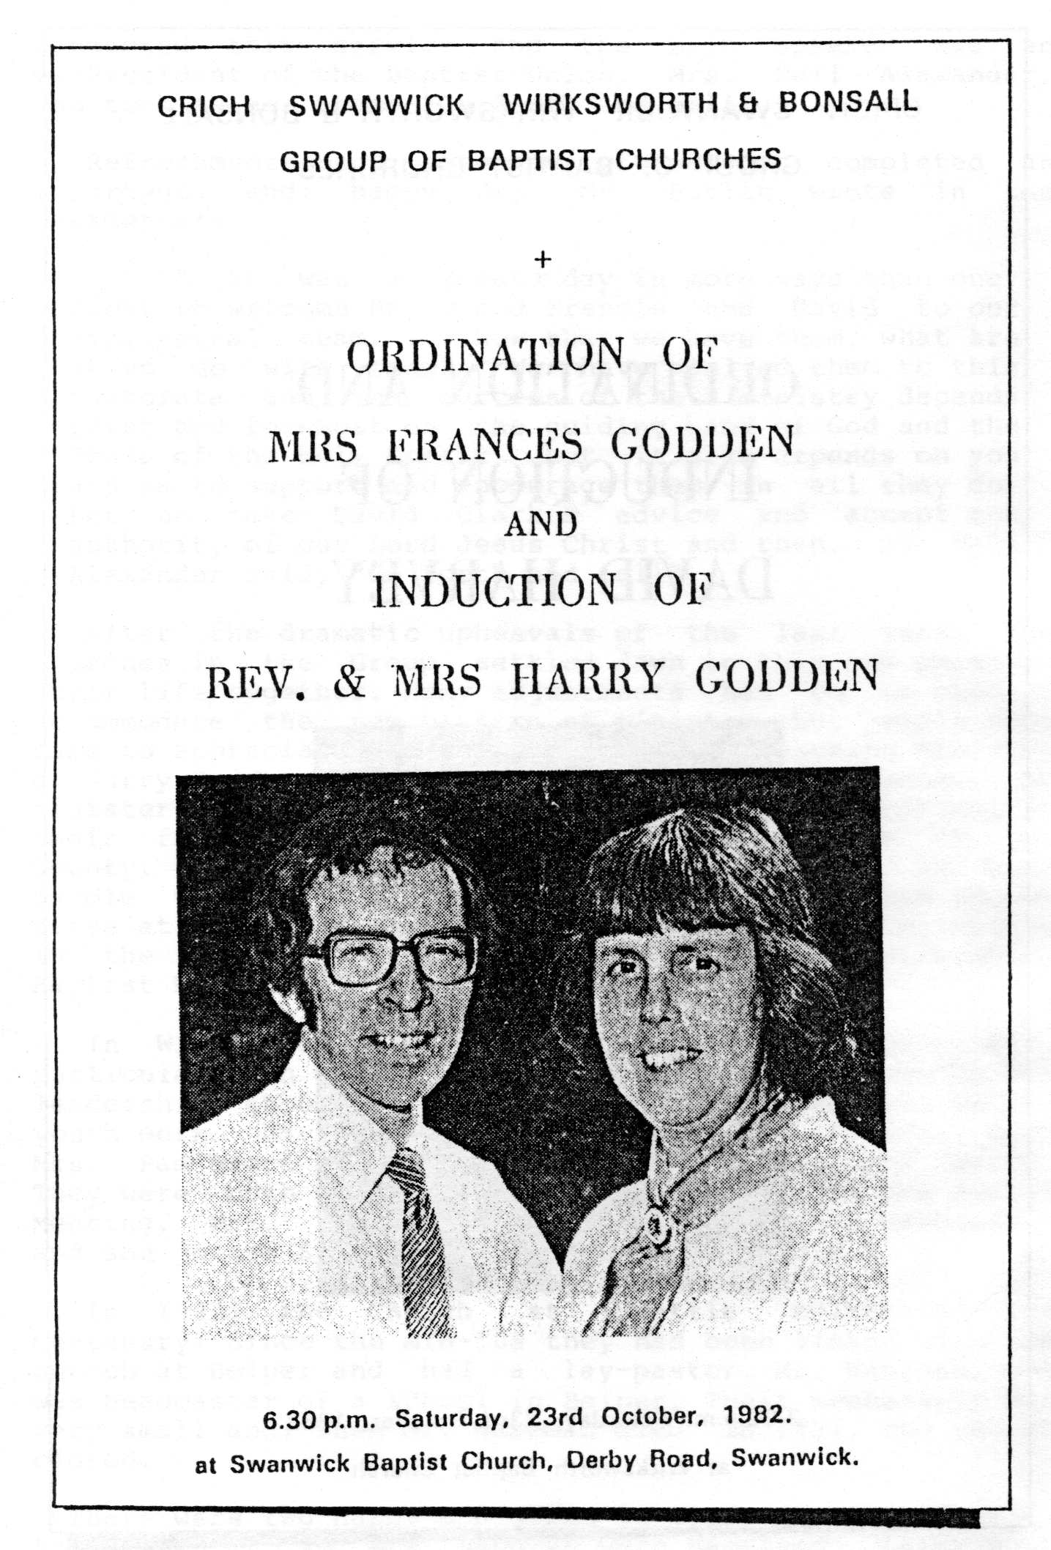Refreshments and speeches of welcome completed an important and happy day. Mr. Butlin wrote in the Newsletter:
" It was a great day in more ways than one. Great to welcome Harry and Francis and David to our ministerial team. ... Now that we have them, what are we to do with them? We have called them to this pastorate and the success of their ministry depends first and foremost on the guiding hand of God and the Power of the Holy Spirit, but it also depends on you and me to support and encourage them in all they do. Let us take David Clark's advice and accept the authority of our Lord Jesus Christ and then, as Nell Alexander said, "Go forth and tell".
After the dramatic upheavals of the last year, the churches in the Group settled down to this new phase in their life together. Many adjustments had to be made to accommodate the new pattern of ministry, but people soon came to appreciate and relish the gifted teaching ministry of Harry Godden and Frances' quiet thoughtful manner. As ministers they had to face many unforeseen problems in their first few months in the Group, and also in the County. They were a great help and strength to many people who appreciated their mature wisdom and common sense at this time. They have continued to minister widely in the County as joint secretaries of the Derbyshire Baptist Union.
In Wirksworth, several changes occurred during 1982, particularly in the C.E. groups. David Harvey gave up his leadership, though he still maintained a keen interest in youth work. David Lancaster became Y.P.C.E. leader, with Mrs. Pam Beech joining him as co-leader for the girls. They were both elected to the- diaconate at the Annual Meeting. Mrs. Hilary Adams was welcomed into membership and she joined Steve Cantwell as leader of J.C.E.
In 1982, the Church at Shottle celebrated its Centenary. Since the mid-50s they had been linked with the church at Belper and had a lay-pastor, Mr. Wakeman, who was headmaster of a school in Belper. Their membership was very small and, when Mr. Wakeman died in 1984, the church closed.
There were two happy occasions in 1983. The first was in April when Mr. and Mrs. Ashurst were baptised. Later that month, Mr. John Butlin was presented with a camera to celebrate 25 years as Church Secretary. He was warmly thanked, not only for the length of time he had served the church, but also for the way he had encouraged and inspired his fellow church members during the difficult days and helped pioneer the setting up of the Group in 1973. He planned to take early retirement from his job at Rolls Royce later in the year. Another retirement, a few months earlier, was that of Mrs. Brocklehurst, who left her job as a dinner lady at one of the town's Infant Schools.
There were soon to be changes in the Sunday School: Mr. Brian 'Randall accepted an invitation from the Government of Lesotho to work there for two years as Commissioner for the Inland Revenue. Mr. Locke took his place as Sunday School Superintendent and Mrs. Locke took over the teenage class.
Many people in the church still felt they would like to become involved in evangelistic outreach and an opportunity came in June 1983, when a Northern Counties Outreach Crusade, with evangelist Duncan Leighton, was held in a marquee in Matlock Bath. Several people became actively involved in visitation, singing and counselling. For several of the young people it was an opportunity to make a public commitment to Christ. Several older teenagers requested baptism and special classes were held for them. In January 1984, Philip Fearn, Teresa Bowmer and Jonathan Naylor were baptised.
Group activities continued in the same way as before, with monthly Fellowship Meetings. In the autumn of 1983, Rev. Harry Godden suggested a joint musical production by the Group, with singers and actors of all ages. Roger Jones' "Greater than Gold" was chosen and rehearsals began. With Frances Godden managing the complicated arrangements and Harry inspiring and conducting, it was an enjoyable time for all who took part. Performances were given in all the churches in the Group and were much appreciated. (A smaller group of singers had the honour of presenting a selection from the musical as part of the opening worship at the Baptist Union Assembly in Nottingham in 1985.)
Several new members were welcomed into the church early in 1984. Mr. and Mrs. Lyndon Collis transferred their membership from Osmaston Road, Derby. Mr. Collis was Mr. Garry Collis's brother, and they had recently moved to a cottage in the hills outside Wirksworth. For many years they had served as missionaries in Zaire. Mr. and Mrs. Robert Few moved from Leicestershire, when Robert joined the staff of the Anthony Gell Comprehensive School in Wirksworth. He and his wife Jenny have three young children: Jonathan, Timothy and Rachel.
In March, Hugh Muschamp and Andrew Winstanley were baptised and, later in the year, it was felt that these young Christians needed a meeting of their own. So "T.N.T". (Teens and Twenties ) came into being. They met for fellowship and discussion and several of them displayed a degree of commitment and maturity in Christ which challenged and refreshed many of the older ones in the church. Miss Ruth Proctor also joined the church at this time. She had been baptised at another church, and she works as a nursing assistant at the local Health Centre. Linda Alton also became a church member, and both she arid Ruth assisted at Christian Endeavour.
In May 1984, Rev. David Harvey became National President of the Christian Endeavour, an appointment which was a great honour for him but also hard work, as it involved him in travelling to many places for special events and services. During the year, he visited Jersey, Northern Ireland, Wales and many places in England; often being away from home for several weekends running. This meant that of necessity his preaching and ministerial commitments in the Group were limited and he was missed by the church.
1984 marked the highlight of Mission England, with the visit of Dr. Billy Graham to several football stadia in the country.
The Wirksworth church took coaches to two of the meetings at Aston Villa, Birmingham. In June 1985, Dr. Graham made a return visit to England, to the Bramall Lane football ground in Sheffield. Many people in the church attended the Christian Life and Witness classes and several also received training for the nurture of new Christians. In conjunction with some of the other churches in the town, a visitation programme was carried out and special prayer meetings were held. Many people went to the meetings and several in particular were blessed and helped by them.
Several of the young people had made a commitment to Christ during a weekend spent at Castleton the previous autumn, and their growth in the faith delighted and encouraged their leaders. In September 1984, a new C.E. group was formed for the 11-14 age group, led by Mrs. Harvey. This meant that there were now four large and thriving young people's groups meeting during the week. Mr. Gavin Muschamp was baptised in November 1984, and Miss Helen Baskerville, Manageress of nearby Willersley Castle, was also welcomed into membership.
In June 1985, the church was greatly saddened by the death of its oldest member, Mrs. Ida Thompson. With her death, the last link with the church of the past was broken. She had been baptised in 1919 and was a member for 66 years. The love and sympathy of the church was extended to Mr. Thompson and the family.
Two happier events in the summer of 1985 were two weddings: the first between church members for many years. On a sunny day in June, Miss Lynne Ashurst married Mr. Andrew Winstanley and, on a cloudy but equally joyful day in September, Miss Linda Alton married Mr. Stephen Bowmer.
The church membership in 1985 stands at 46, with the welcome addition in the autumn of Mr. Bill Bowmer, who, with his wife Jenny, was baptised in October. The church welcomed back members of the Randall family after their stay in Lesotho.

And so the story of Wirksworth Baptist Church comes up to date. As we look forward to the centenary of the building in 1986, there is much for which to praise our God:
For the faithfulness and vision of the people who established the church and built it a hundred years ago. Some of their names appear in these pages; others are not mentioned by name, but they are all part of the family of the church.
For the dedication and hard work of the handful of members during the "lean years". They were sometimes discouraged, but they never lost their faith, and they preserved the identity of the church and its buildings for the time when God again brought blessing.
For the wisdom and vision of those who brought the Group into being, and for the inspired leadership of Rev. Brian Nicholls in the early years.
For the many people whom God has brought into the church in recent years, with their many and varied gifts which enrich the fellowship.
For the mature and balanced leadership of Harry and Francis Godden.
What of the future? We are looking with confidence to God to lead us as we enter a new chapter in the life of the church. We praise Him, for the way He has led and inspired His people in the past, and for the many wonderful things He has done in the lives of His people in Wirksworth Baptist Church over the years. At a conference day held in January 1986 at Willersley Castle, many aspects of the life of the church were discussed and there was a desire among the whole fellowship to move on and grow - both in commitment to God and to each other as brothers and sisters in Christ. And so as we celebrate the centenary of the building we are reminded that we are called to be "living stones", as Peter writes in his First Letter:
"Come as living stones, and let yourselves be used in building the spiritual temple, where you will serve as holy priests to offer spiritual and acceptable sacrifices to God through Jesus Christ."

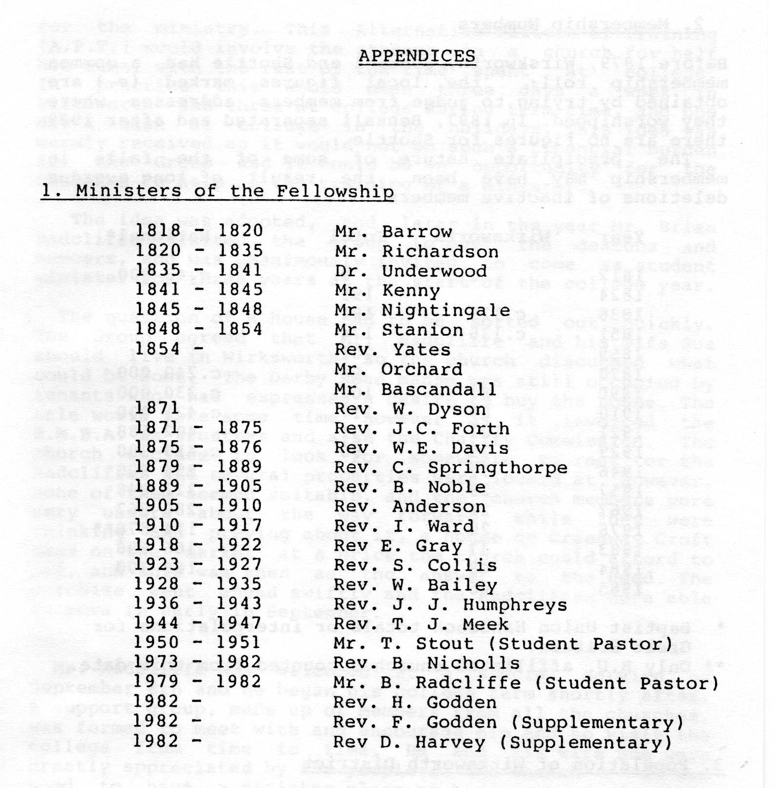

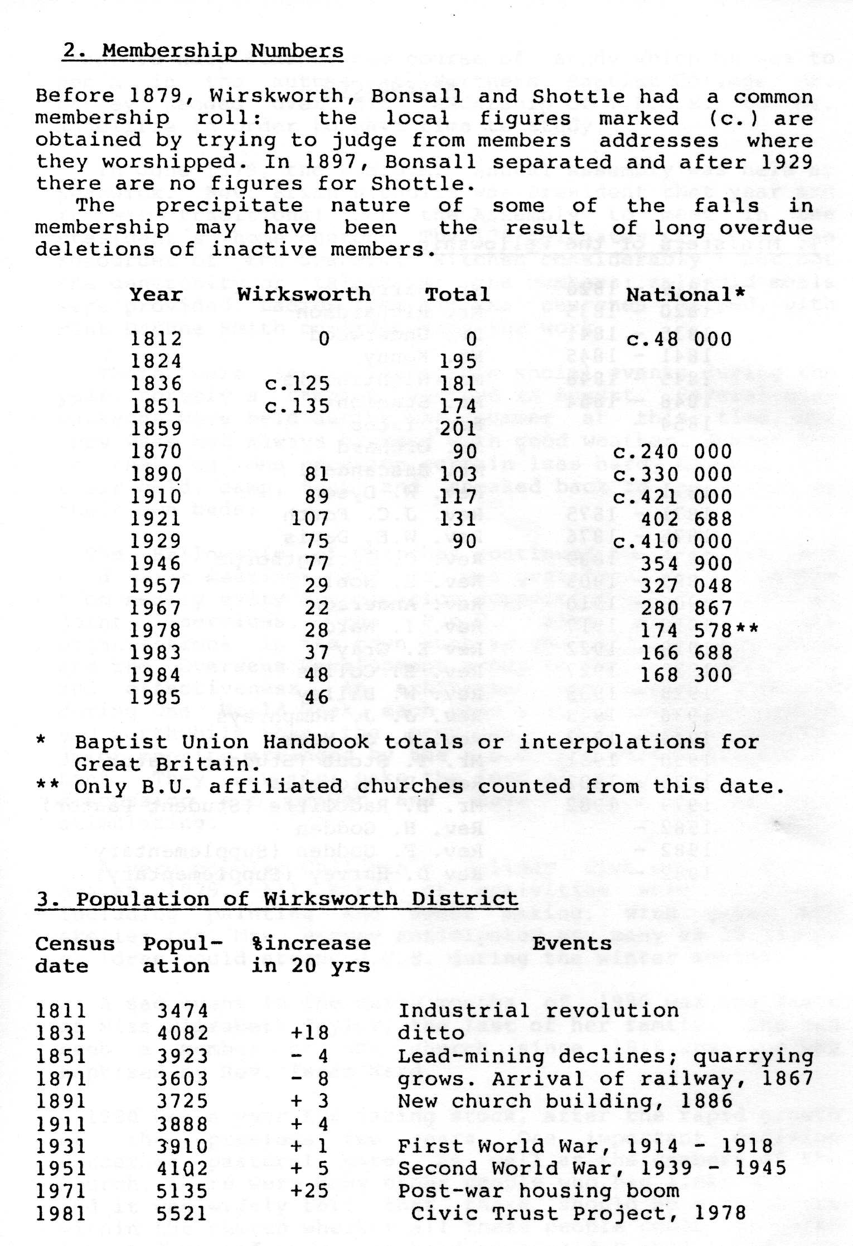

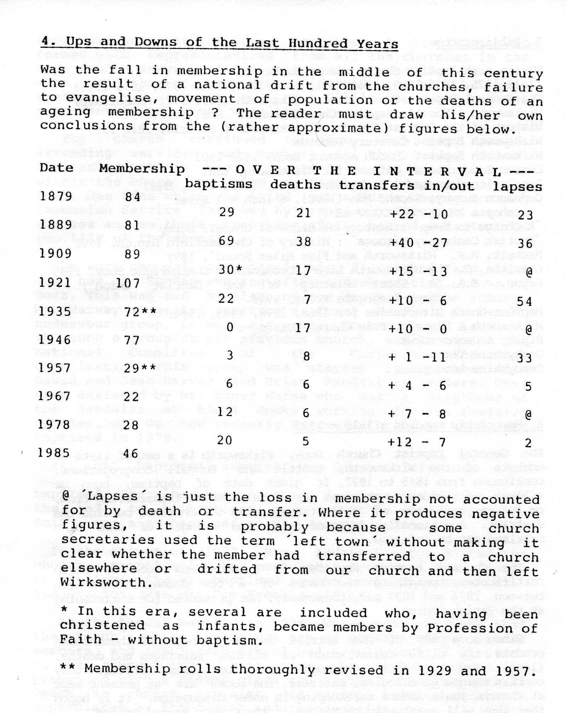

5. Bibliography
Wirksworth Baptist Church Minute Books
(1818-1825, 1836-1859, 1860-1921, 1922-1951, 1951-1972, 1973-1985)
The General Baptist Church Book, Wirksworth (1818-1922 Membership)
Wirksworth & Shottle Baptist Church Members' Roll (1929- )
History of the Baptist Church at Wirksworth & Shottle, 1818-1918
Wirksworth Baptist Cemetery Records
Wirksworth Baptist Church Account Book, 1822-1903
Census Enumerators' Returns for Wirksworth, 1881
Population Censuses : Derbyshire, 1961, 1971, 1981.
HMSO Ordnance Survey, Second Edn (1890), 6 inch = 1 mile:
(sheets XXXIX NW, XXXIV SE )
'A Charge to Keep' : History of Brook St Chapel, Derby
'Baptist Centenary Witness' : History of Chesterfield Bap.Ch. 1961
Hackett, R.R. 'Wirksworth and Five Miles Round'. 1899
Charlton, C.'The Wirksworth Line', Cromford Ch & Arkwright Socy. 1985
Payne, E.A. 'A Short History of the Baptist Union',
Carey-Kingsgate Press, 1959.
Baptist Union Directories for 1968, 1978, 1983, 1984.
Wirksworth & District Free Church Messenger
Ripley & Heanor News
Derbyshire Times
Derbyshire Advertiser

6. Membership Records : 1818 - 1922
The General Baptist Church Book, Wirksworth is a set of lists of members of the Wirksworth, Shottle and Bonsall congregations, continuous from 1818 to 1922. It gives date of baptism, town or village of residence, previous residence of those transferring from, or future residence of those transferring to, churches outside the district. Additionally, dates of death and changes of name upon marriage can be inferred.
The General Baptist Register is a pro-forma book of birth certificates, containing the names of a few dozen infants born between 1824 and 1837 and, presumably, not presented for christening at the Parish Church.
Since some 500 of the entries in one or other of these books predate the civil registration of births, marriages and deaths, (1837), and the first thorough population census, (1841), they contain unique genealogical material. The books are at present kept at church. Their future safekeeping is under discussion. It is hoped that they will eventually be placed in the County Record Office.
The Baptist Cemetery, still in use, contains headstones dating from about 1853, mostly still legible. A transcription of the names and dates will be put with the other church records.

